SCOUTSTRACKER – HOW TO

EDIT AN EVENT TO ATTACH ERP & AAF version Feb 5, 2023

ERP - Emergency Response Plan
AAF - Adventure Application Form
-log into ScoutsTracker, go to your section
-starting from the home page, click on Beaver Edition, then click onto schedule
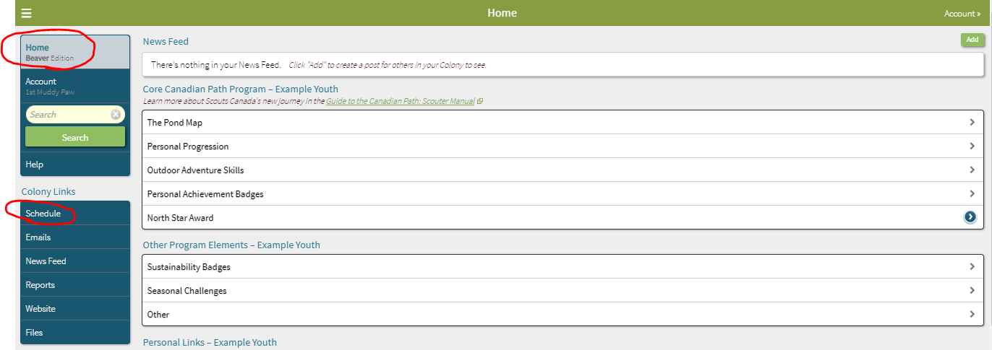
- click on the date you want to edit
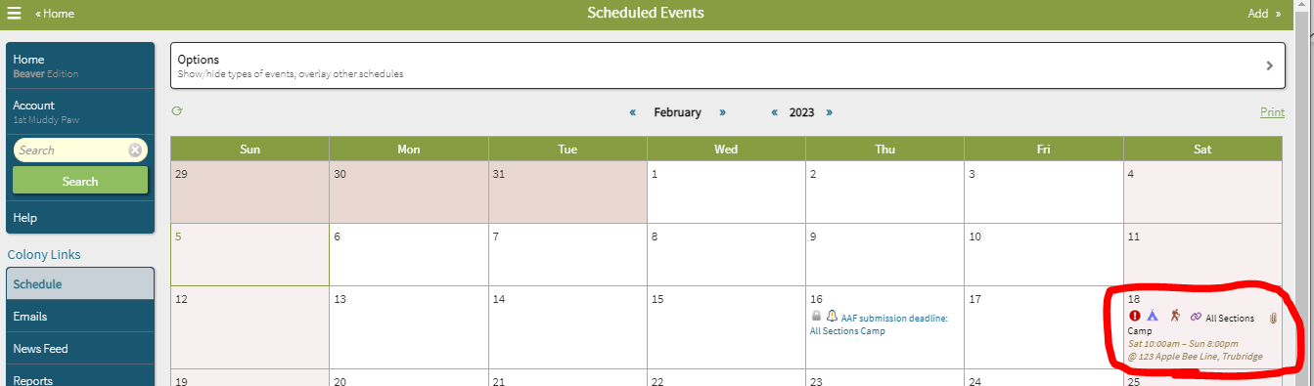
- click on “Edit” at the top right
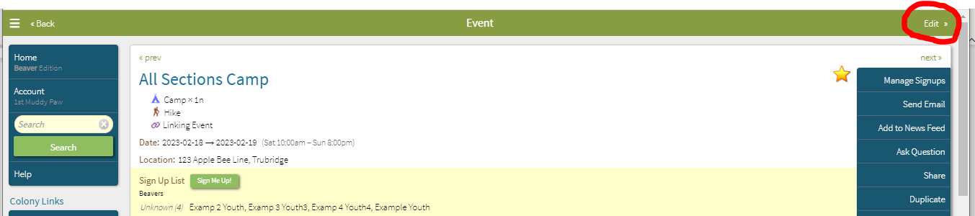
- an option will appear as seen in screen below
- click on (modify)
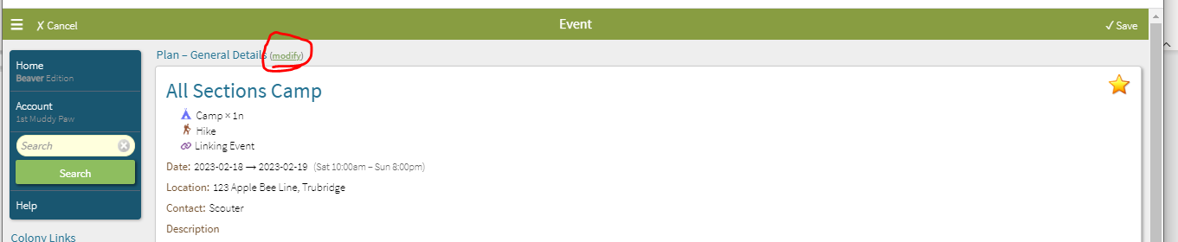
- see screen below, everything in this event is now open to edit
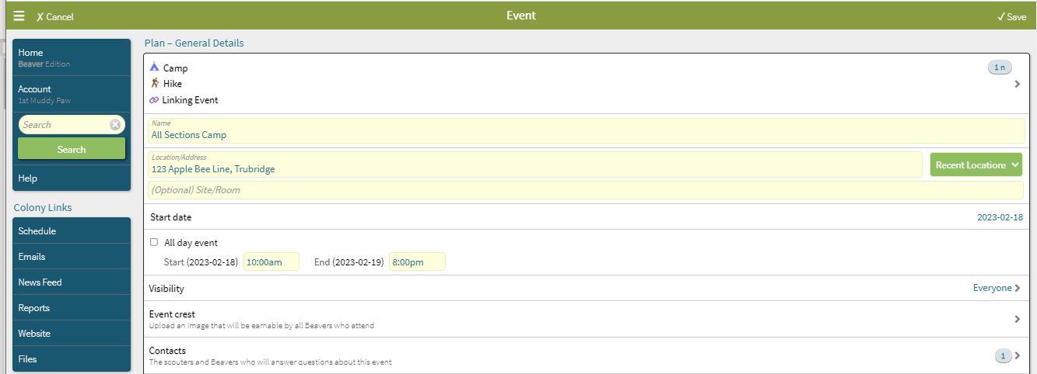
- scroll down the page to the Plan – Risk Management section
- this event hasn’t happened yet
- prior to the event I need to attach the Emergency Response Plan (ERP),
-prior to attaching your ERP ensure it is up to date and has the correct information for this specific event, such as address of event, medical locations, etc.
- now click on Attachments, the below screen will open up
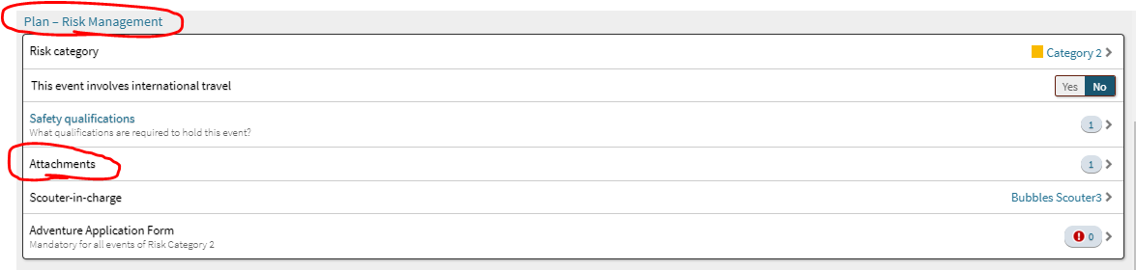
-you will see the below screen
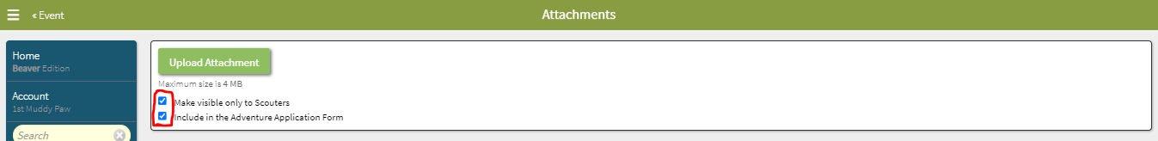
- these 2 boxes are choices; you want to include the form with your Adventure Application Form
- make visible only to Scouters – I like to choose this one because if this portion is filled in then this is confidential information and shouldn’t be shared with all parents
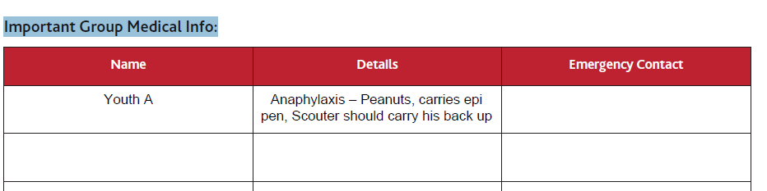
- to select each, you just click on the boxes and a check mark appears
- next click on Upload Attachment
- a screen will open for you to find the file on your computer, click on file to upload it
- you will now see the screen below
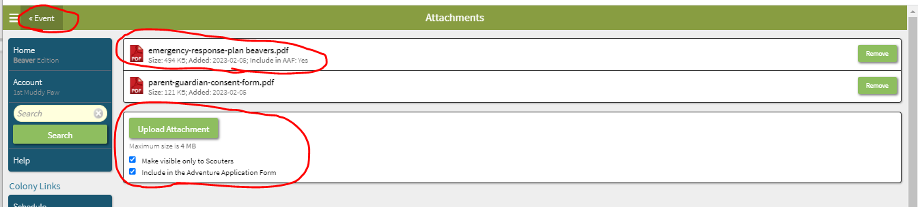
- if this is the wrong file you can Remove it by clicking on the right and then Upload Attachment again with the correct file
- now this is done click on Event at top left to go back to previous page
- you will now see the below screen and there are 2 attachments, the Parent Consent form and the ERP
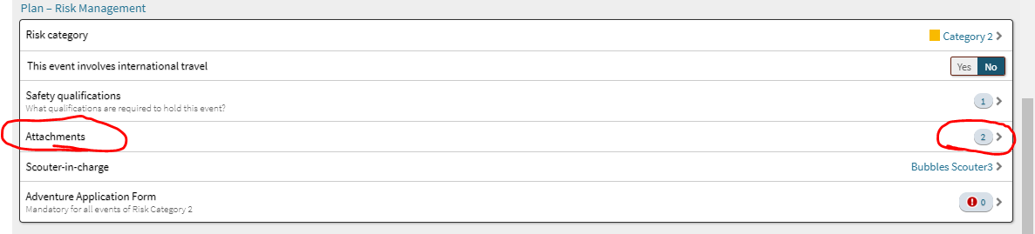

Adventure Application Form (AAF)
- this event is a category 2, so an AAF needs to be submitted
- click on Adventure Application Form
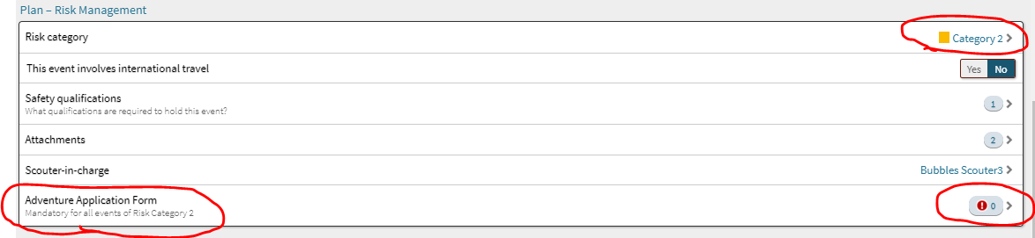
-the below screen will open then you have 2 choices
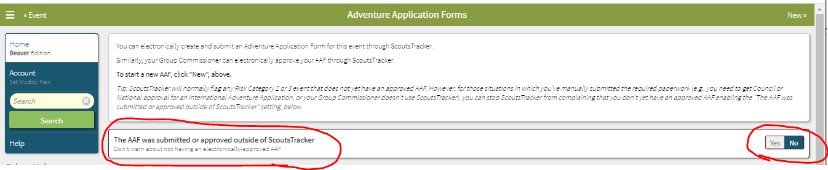
1. The AAF was submitted or approved outside of ScoutsTracker.
- I don’t recommend this because you will have to manually fill in all the information in the
form and look up every member # in myscouts, etc.
2. If you submit the AAF through ScoutsTracker:
- then ScoutsTracker will fill in the form for you
- this also helps to eliminate errors in transposing information
- saves time
- it will also email the form to your Group Commissioner for approval with the ERP attached
- it will save a permanent copy of the forms section of ScoutsTracker
-choose No
-go to the top right side and click on New
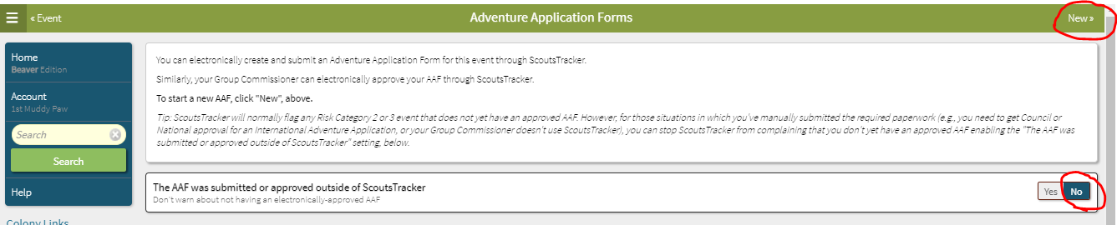
- you will now see the below screen open with the AAF form, the form has a lot of information populated but it isn’t complete yet
- you will need to scroll down the form and ensure everything is complete and answer some of the sections
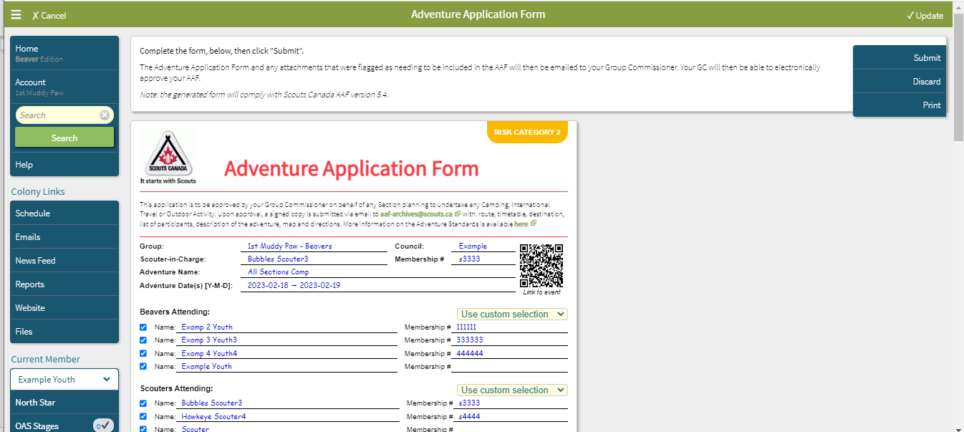
- to start you can see this part of the form is missing 2 membership numbers, this means your ScoutsTracker files are not up to date
- at this point you need to exit this form and go back and update the members files by either typing it into ScoutsTracker or downloading the information from myscouts.ca
- I would suggest downloading the information because you may be missing other information as well
-we now have all the information completed in ScoutsTracker
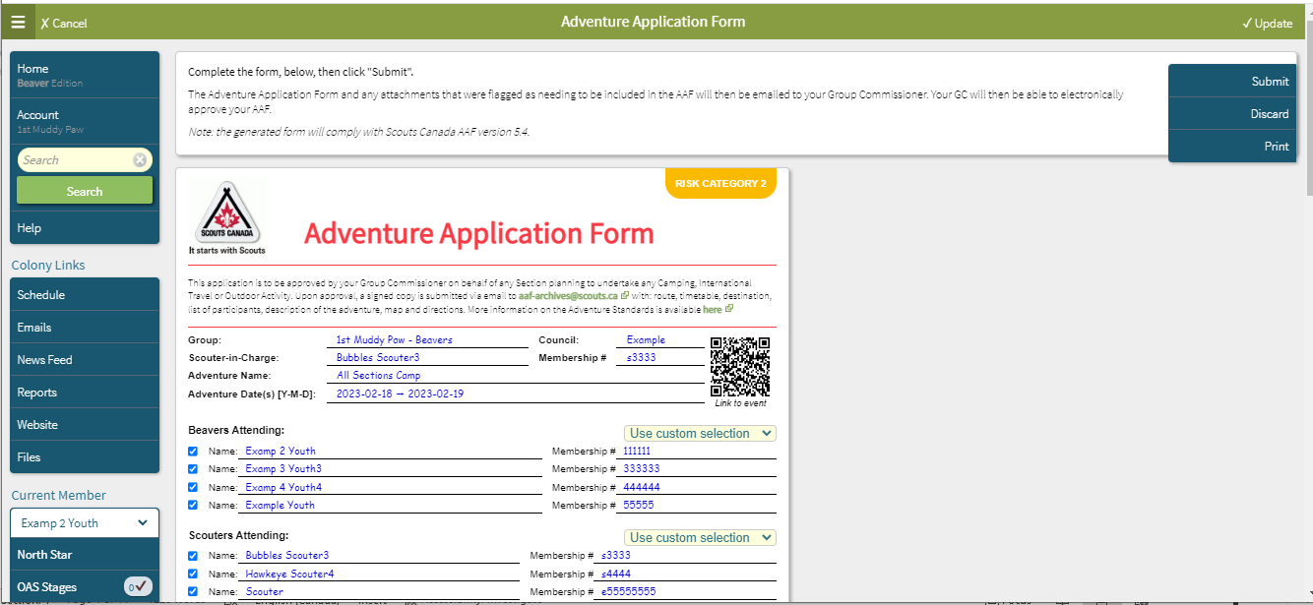

- who is attending, there is a drop-down menu which will give you options on where ScoutsTracker pulls the attendance from
- Use custom selection – will populate all the participants in the section
- None attending – if this was a scouter only event and no youth were attending
- Use signup information – will populate all the participants in signup list
- Use attached list – if you created a manual list and put it in attachments
- you can also click on the boxes on the left and put check marks for those who said they were attending
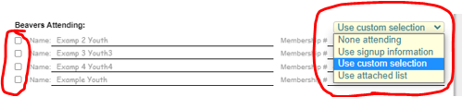
- once you have completed attendance scroll down the page
- in the screen shot below, you can see in the blue circles the information that self populated
- in the red circles are options for you to answer
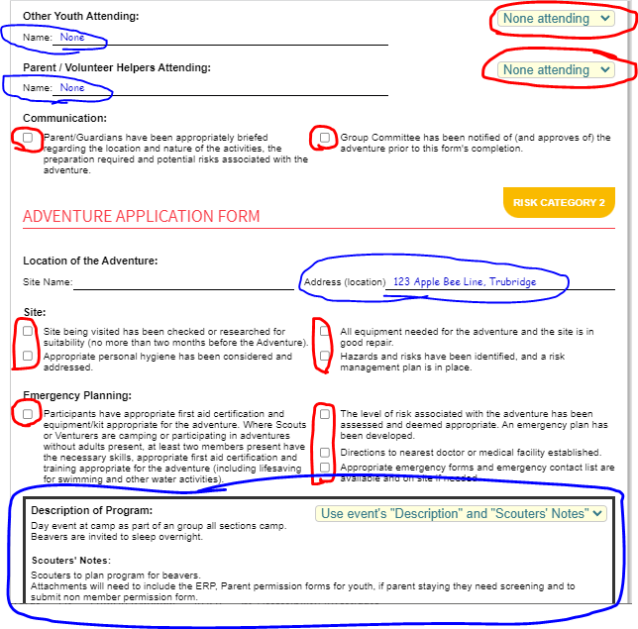

- as you scroll down further in the form you will see the below screen with more information
- you can see in the blue circles the information that self populated
- in the red circles are options for you to answer
- beside the red arrows are links to the scouts.ca national website if you need to check further details of information
- at the bottom you will see Scouter-in-charge, who will fill out this form and this box
- you don’t fill in anything in the Group Commissioner box

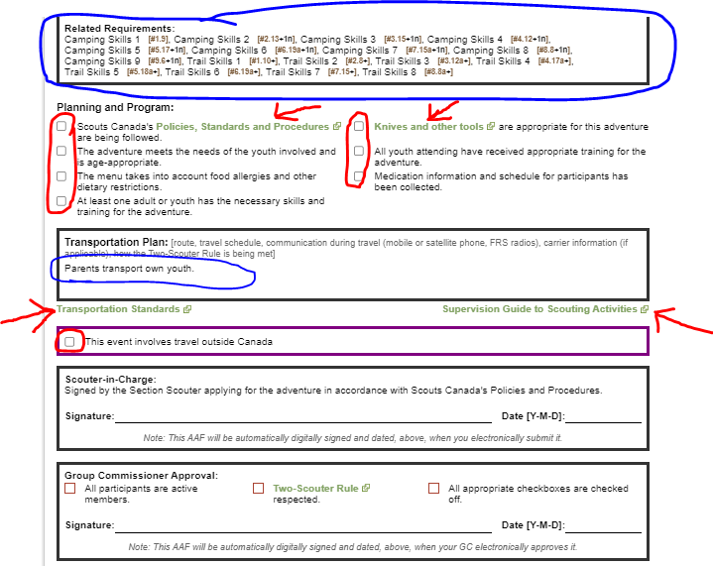

- scroll down further in form
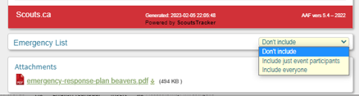
Emergency List - you have a drop-down menu choice here
Don’t include – won’t include any emergency information for the participants.
Include just event participants – will include the emergency information for the participants.
that signed up.
Include everyone - will include the emergency information for ALL the participants in your
section
- it is up to you if you use this or not, whether you do or not you should always have a printout of the youth & scouters registration forms from myscouts.ca which gives the full information of each youth with you at all times when youth and scouters are present
- if you choose to use option 2 or 3 then when you click on it you will get a pop-up screen asking you for your PIN
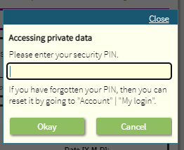
- type in your PIN and click on Okay, you will then see the list appear
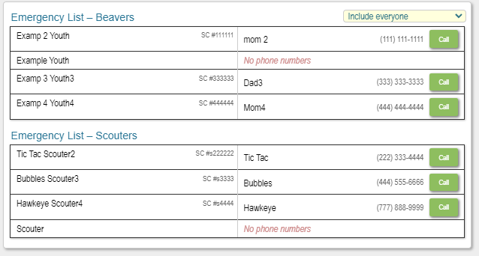
- you can also see here that your ERP is attached to this form
- now the form is complete and its time to submit it
- scroll to the top of the page on the right side click on Submit
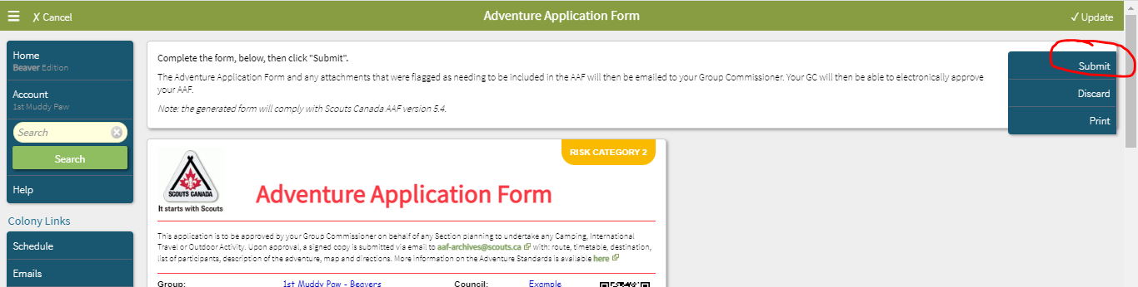

-once you click Submit there will be a pop up that says Saving Event details
-then you will see the screen below with some options
-ensure your GC name is correct
-if you have any added comments to send the GC there is a box you can type in the comments
-ensure your name is correct here
-type in your ScoutsTracker password
-then click on Sign and Submit the AAF
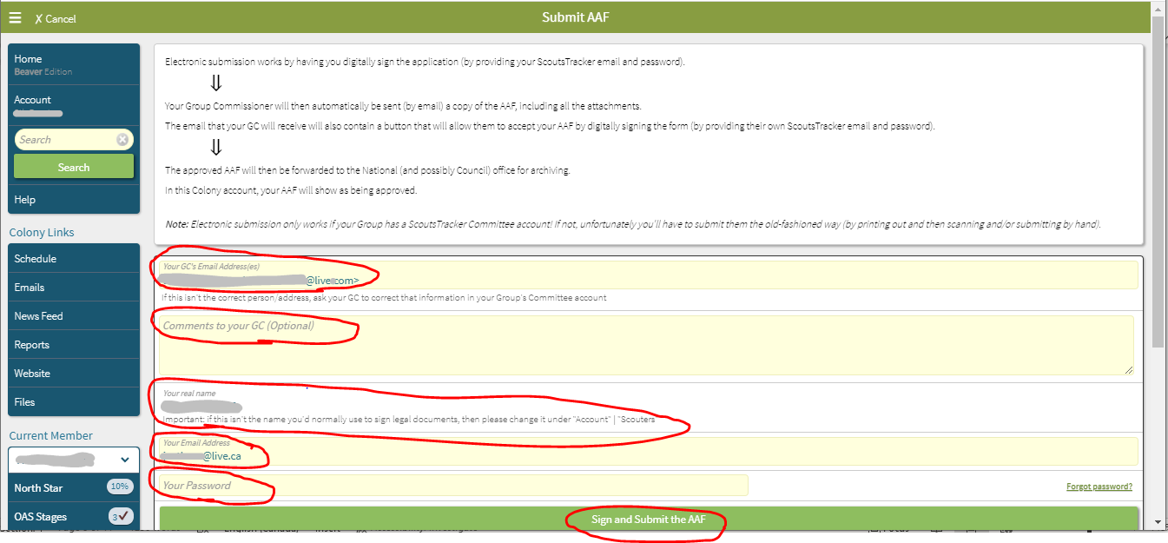

-you will receive a pop up if this is right then click on Okay
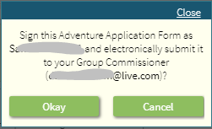
-you will get a pop up that says Submitting AAF
-then you will get another pop up that says
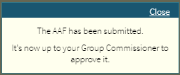
-the form is now submitted, and you can back out and sign out of ScoutsTracker

THE END

