IMPORT RECORDS TO SCOUTSTRACKER
-to import youth and scouters information from myscouts.ca into scoutstracker.
**-ensure that only 1 scouter in your section is doing this so you don’t duplicate or erase current
records in scoutstracker
-login into “myscouts.ca”
-in myscouts.ca under “My Menu” and scroll down to “Reports”

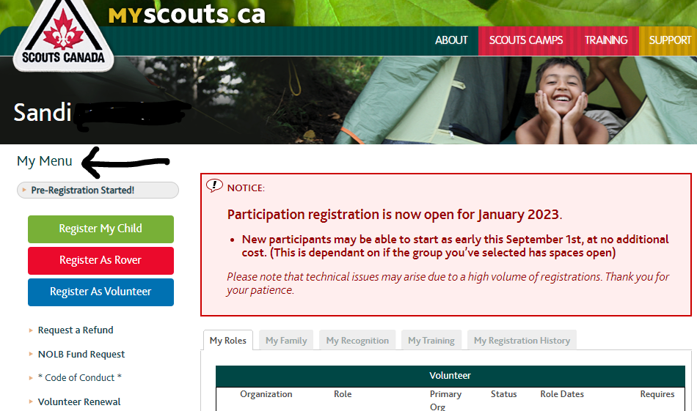
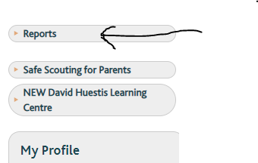
-click on “Reports” to see the next screen below
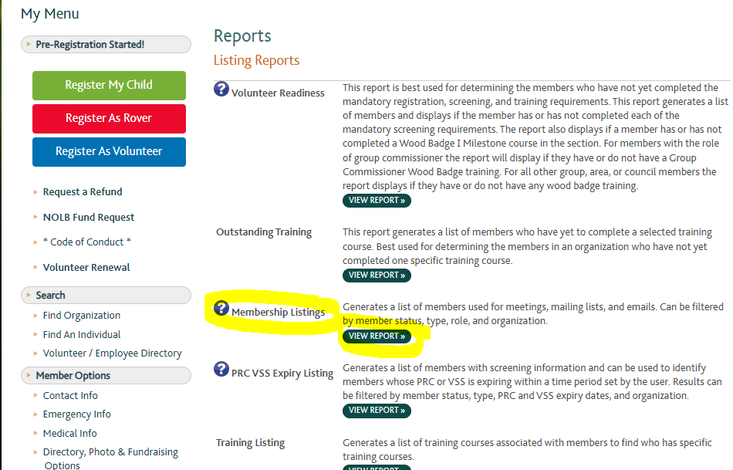
-beside “Membership Listings” click on “View Reports” you will get the below screen.
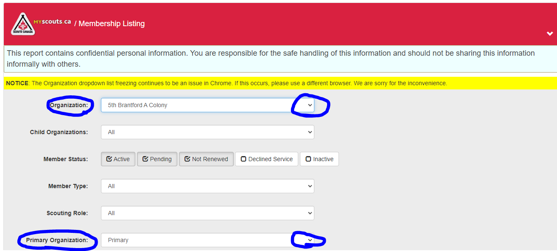
-beside “Organization” use the dropdown menu to change it to the single section you want. In this
case I want the Colony section.
-then beside “Primary Organization” use the dropdown menu to change it to the “All”
-next, scroll to bottom of your screen and on left side using the drop down menu, change “To Screen”
to “EXCEL”
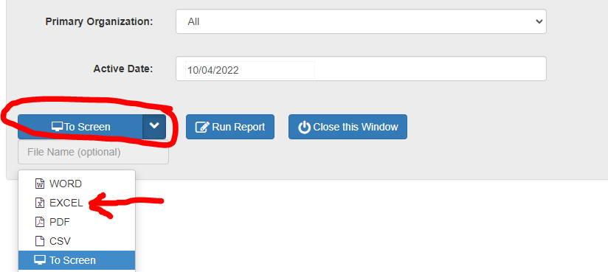
-then type in file name whatever you want to call the file.
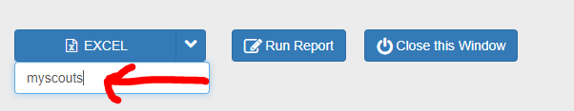
-now click on “Run Report”
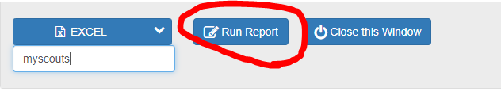
-when the report is ready you will see it at the bottom left of your screen.
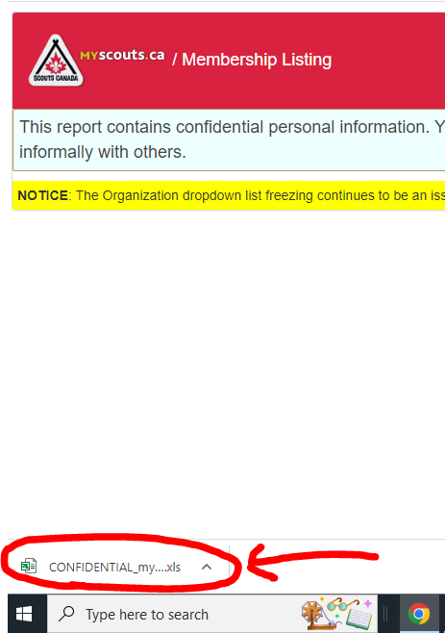
-then click on the file and it will automatically open up in your excel program on your computer.
-now you adjust the spreadsheet in excel. Delete anyone you don’t want to download into scoutstracker. Example: If you already have that person in scoutstracker you don’t want to download them again.
-now that the Excel spreadsheet only contains the files you want to download to your scoutstracker section save the file on your computer.
-then go to scoutstracker and click on “Import from myscouts”
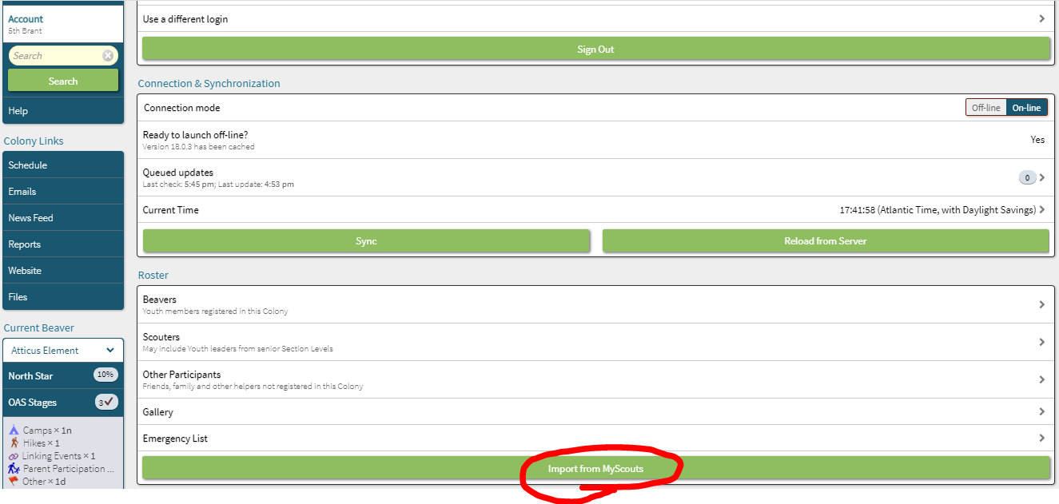
-you will now see the below screen next
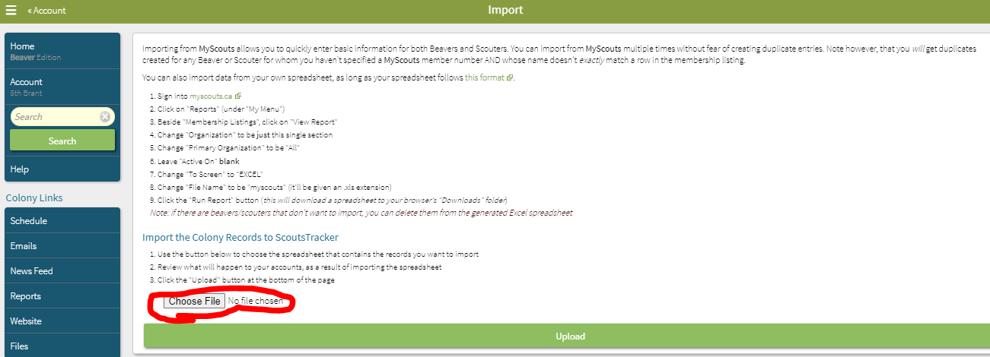
-click on “choose file”
-find the file you want, select it, then click open
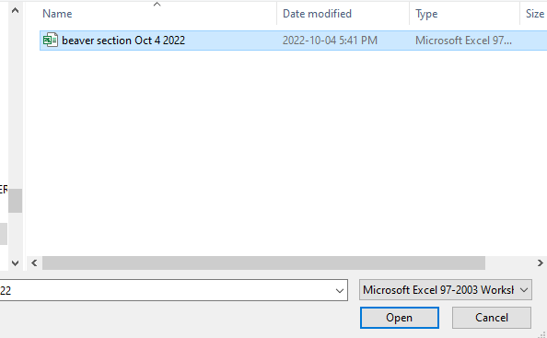
-go back into myscouts and you will see this screen below, it has updated with the information
-you will actually see the names but I blacked them out for privacy reasons
-double check that this is the correct records you want to upload
-if all is good then click on “Upload”
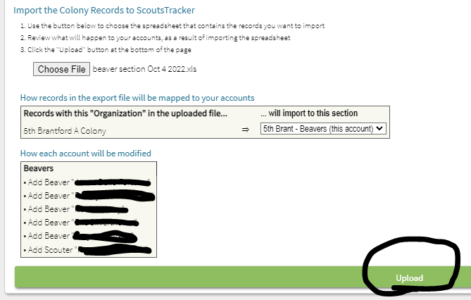
-you will now see a pop up box letting you know this action can only be undone manually so ensure
you double check you have the correct files
-if you upload a youth that is already in scoutstracker you will erase any updates/records that are in scoutstracker so be cautious
-if you are sure then you can now click ok
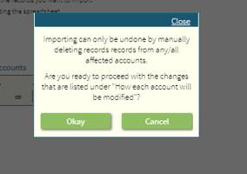
-after clicking ok you will see the screen below where the files are now uploading
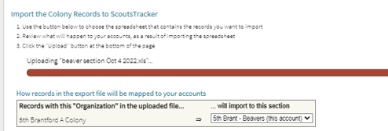
-once the upload is complete you will get a pop up box as shown below
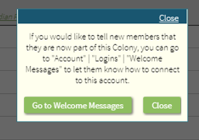
-this welcome message sends an invitation to the people in the newly uploaded files giving them an invitation to log into scoutstracker. You can also customize the email to add any additional information you would like to
-click onto “Go to Welcome Messages”
-the new people will be automatically checked off as well as anyone who hasn’t received a previous welcome email.
-send your email then your done, close out of scoutstracker
-log out of myscouts.ca

