SCOUTSTRACKER – HOW TO
FOLLOW UP ON RSVP EMAIL AND PRINT OUT ATTENDANCE SHEET
version Feb 6, 2023
After the email goes out with the RSVP in it.
-the screen below shows what scouters and parents receive
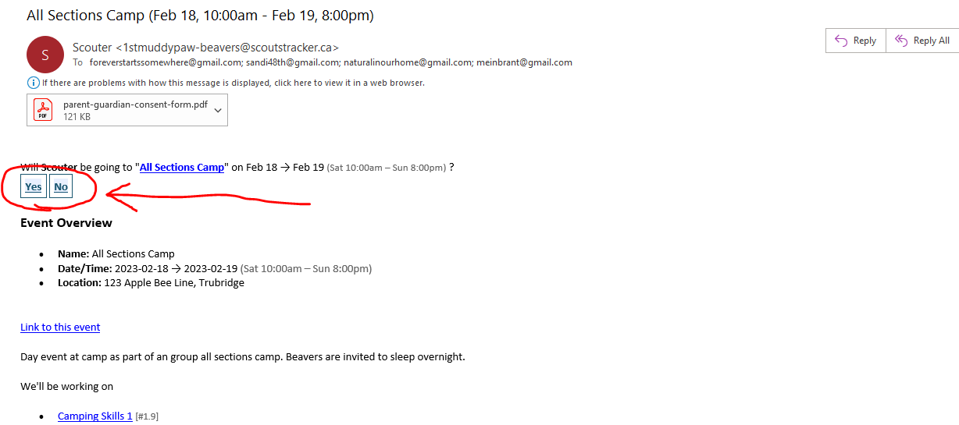

-you can see where the RSVP buttons showed up in the email
-once the parent / scouter clicks on their answer, there will be a pop up
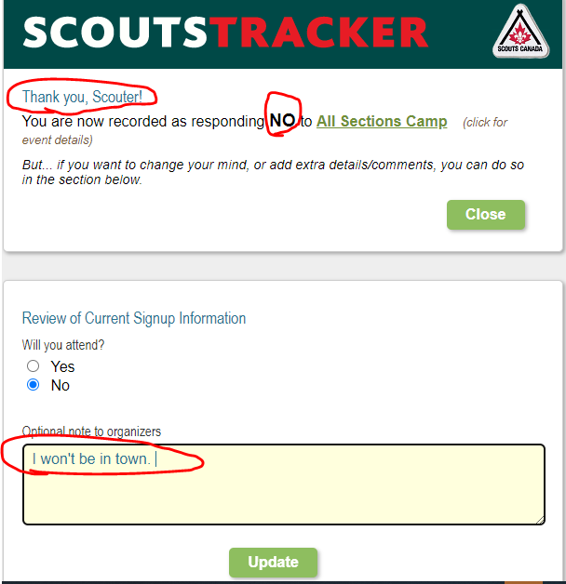
-this shows who I am “Scouter.”
-it shows I responded with a NO
-I put a comment into optional note to organizers
-then click on Update and you get another pop up
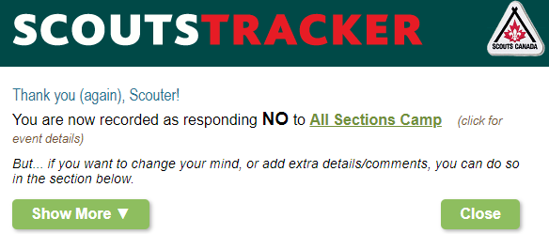
Now lets go into ScoutsTracker to see where this response shows up.
-sign into ScoutsTracker and go to the Schedule
-click on the day you want to see the RSVP for
-on the right side click on “Sign up / Attendance.”
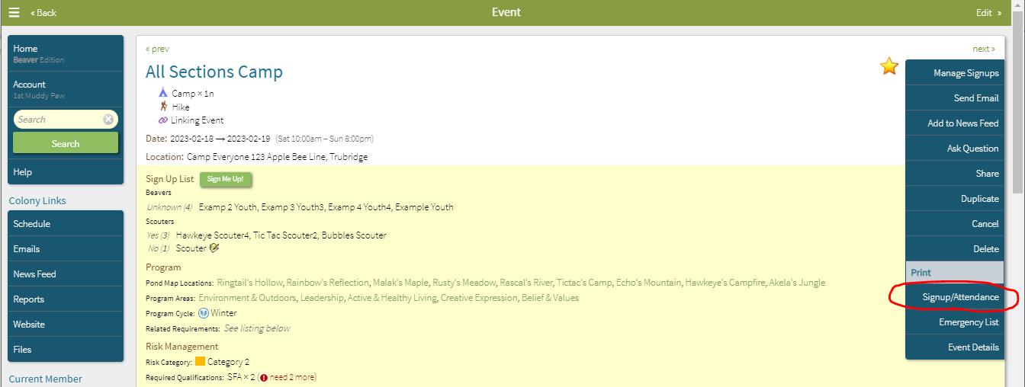
-the following screen opens
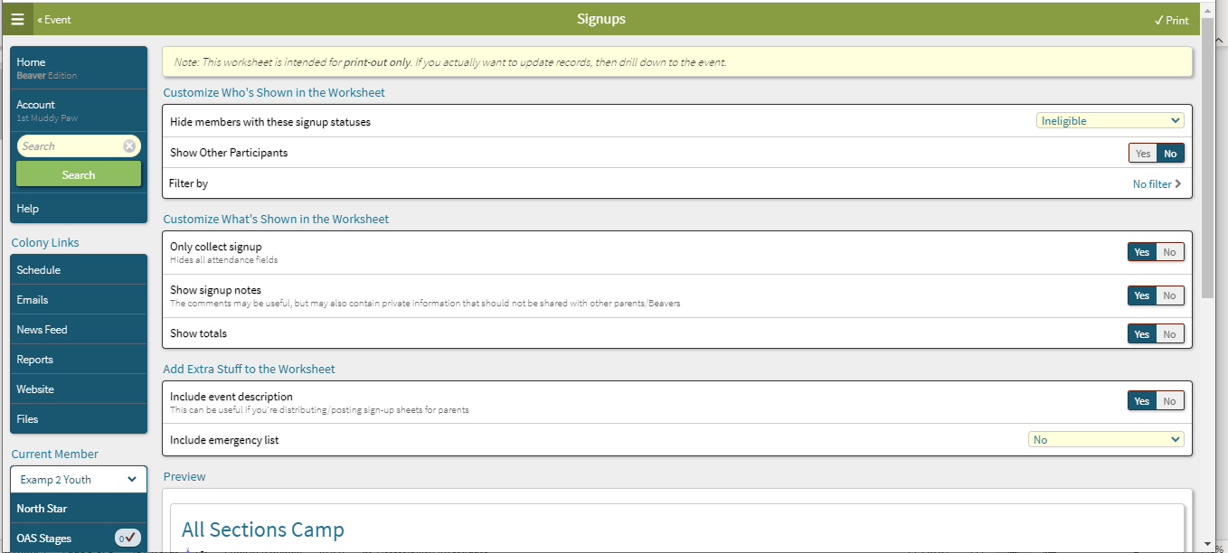
-then scroll down the page to see the below screen
-here you see the email responses already recorded in ScoutsTracker along with the one note that was added by one of the scouters

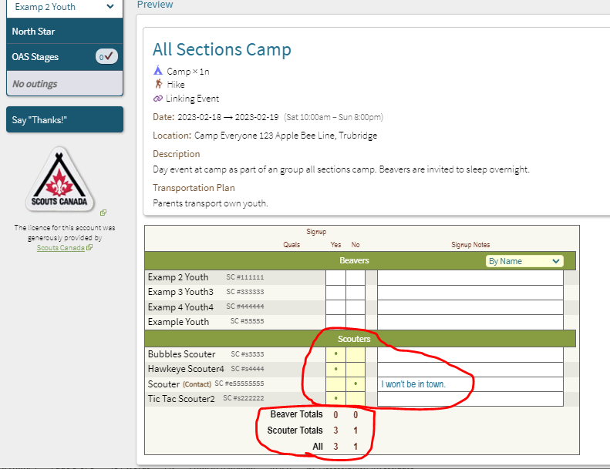

-scroll back to the top of the page
-you have several options on this page for the most part you can answer yes or no
-then you can print out the sheet, take it to your event and take attendance
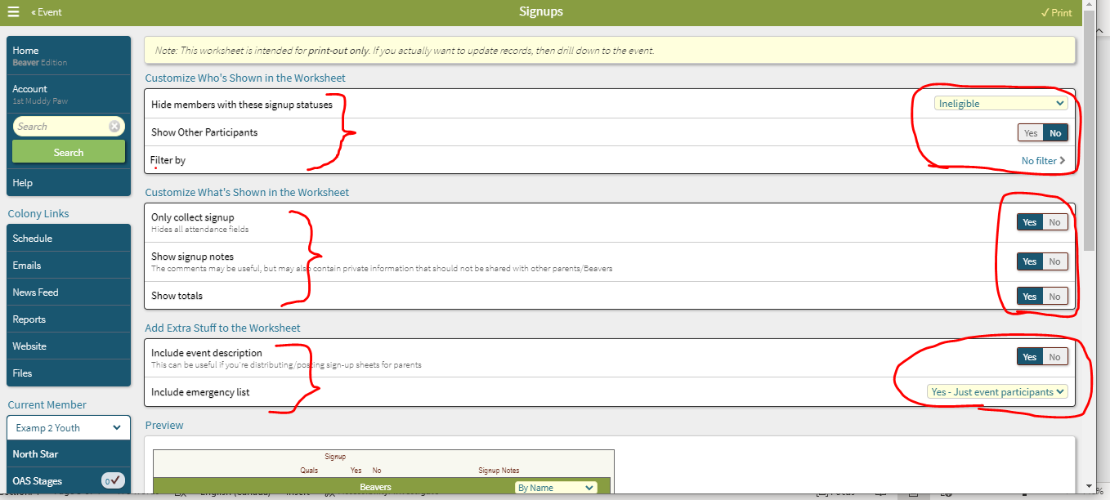
-below is the printout without the emergency list
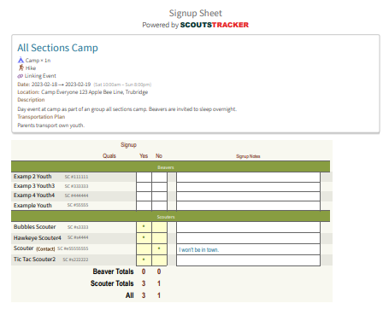

-below is the printout with the emergency list
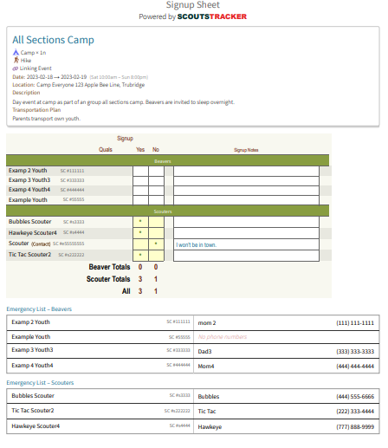

Once you are done here you can just go back and sign out of ScoutsTracker.

THE END

