SCOUTSTRACKER – HOW TO
SEND EMAIL WITH AN ATTACHMENT AND RSVP
Group: 1st Muddy Paw Version: Feb 5, 2023
-go to scoutstracker.ca you will get the screen below.
-then click on the section you want, this instruction will be done in the Beaver Scouts section
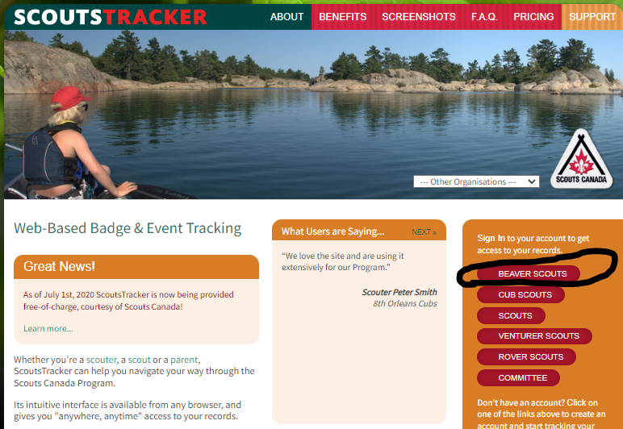
- enter your email and password
- then press enter key on your keyboard OR click on the green sign in bar
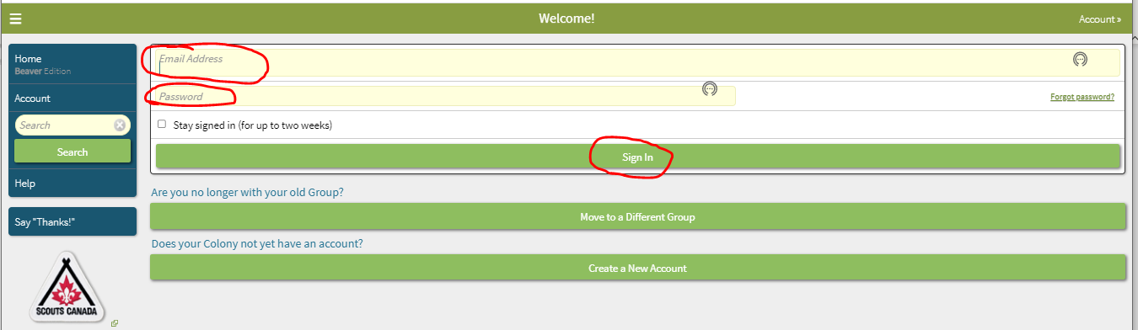
- the below screen will come up, then click on “Schedule” on the left
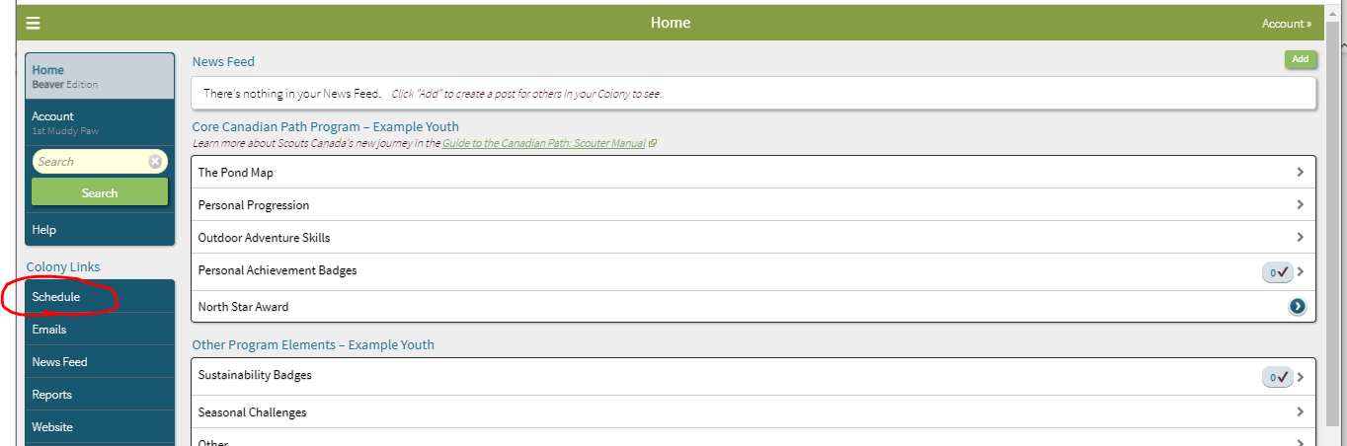

-click on the date that you want to send the email about, don’t click on the +
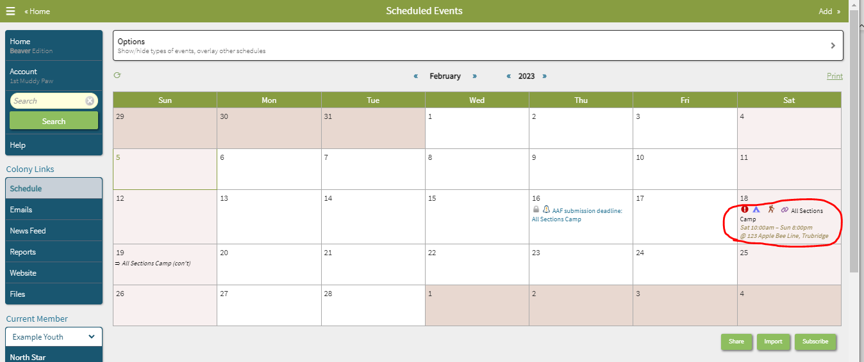
-see screen below
-ensure all the details of the event are correct or if you want to add or edit anything do it now before sending email
- if all details are correct then click on “Send email” on the right side
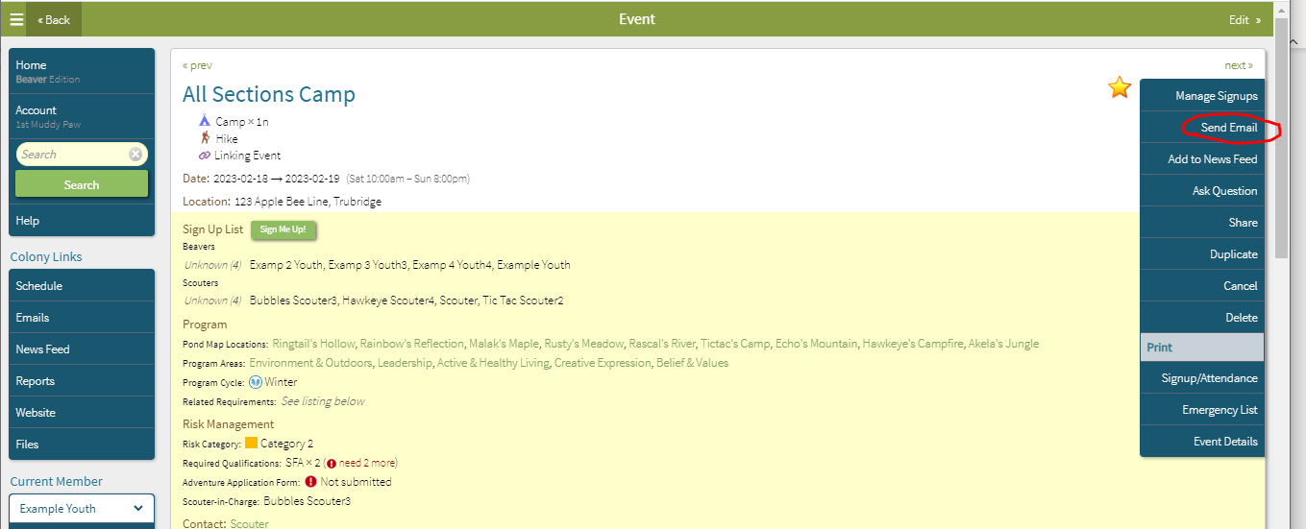
- you will see a pop up
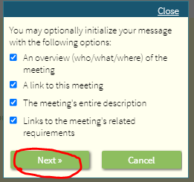
-go through the checklist and click on each box you want to add to the email, clicking on boxes will put check marks in them
-if you don’t want something in the email then leave the box blank
-then click on “Next.”
-the below screen will open up
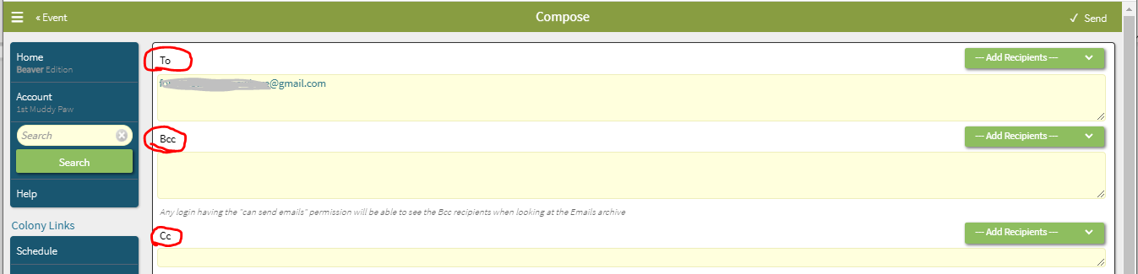
-you now have email options
1. TO – I use this for the scouters email addresses, either mine + 1 other scouter or mine & the rest of the Scouter section team (you must have at least 2 scouters on each email for ScoutsTracker to send an email
2. Bcc – Always put the parents’ emails in this section for privacy reasons from other parents
3. CC – If I only put 2 emails in the “TO” section then I will put the rest of the section scouter
team in this section

-to fill in the emails, you don’t have to type them all in
-click on the right side to see the drop down menu and choose the appropriate people for each section of To, Bcc, Cc
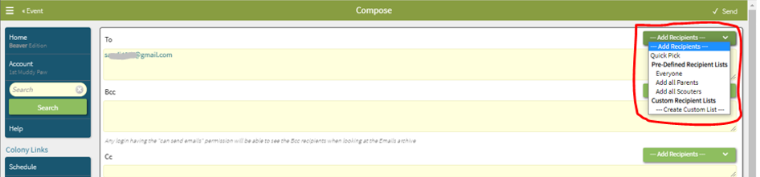
-then scroll down to the “Reply To” section, see below screen
-anyone who replies to the email you are sending out, the person’s email here will receive the responses
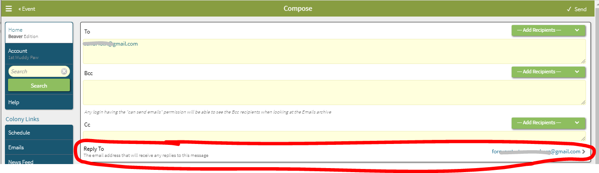
-now scroll down to the RSVP section, see below screen
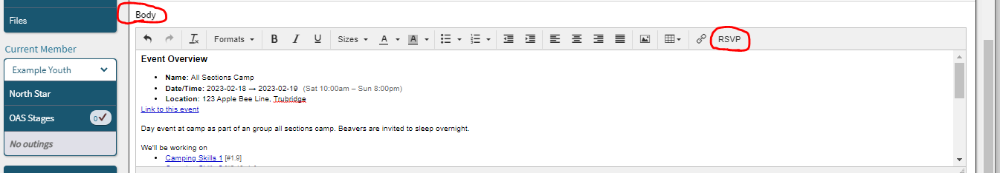
-this allows you to put an RSVP button into the email for everyone to respond to
-the RSVP options are Yes, No, Maybe (I don’t like the maybe because it makes it harder to plan, but it is up to you)
-the RSVP is a great feature so you can get numbers for your event and see who has responded and who hasn’t
-when everyone clicks the RSVP answer in their email , it will automatically send the response back to ScoutsTracker and record it in the attendance sheet, it also records any comments the parent may answer with
-this is a great timesaver from you having to manually track attendance and anyone on the scouter team can see the up to the minute response list just by signing into the event date in the schedule
-when you click on the RSVP to add it to the email you will receive a pop up, click close
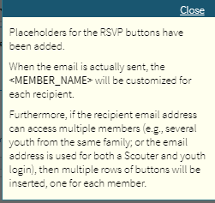
-you will now see the below screen with the RSVP button in the template you are creating for the email
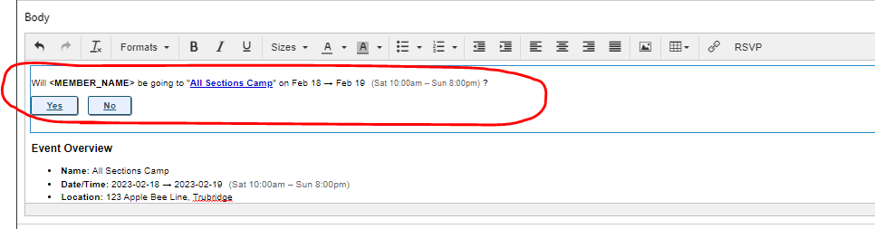
-next you have attachments, see next screen below
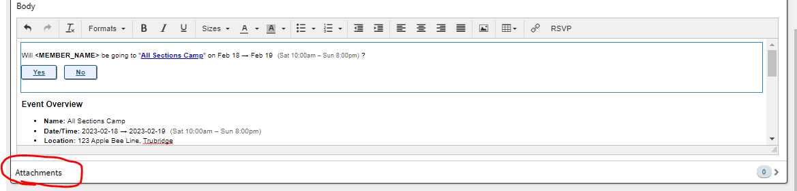
-this can be used to attach a permission form, direction map, an electronic pamphlet from where you are going, any type of file you would like to send to parents
-this option is great; it will save on printing out paper and wondering if everyone received the handout or lost the handout
-scouters and parents will all receive the attachments
-because this is an overnight camp, I am going to attach the parent/guardian permission form
-once you click on “Attachments” the below screen will open
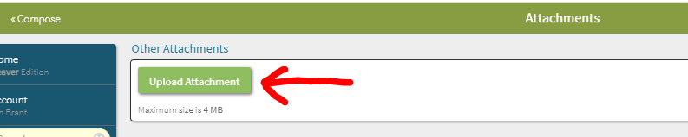
-click on upload attachment
-go find the attachment, attach it
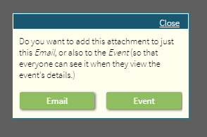
- you will get a pop-up box and click on which one you decide
-below, you will now see the attachment is there, if you change your mind or attached the wrong one you can go to the right and click on remove
-you can attach multiple attachments if you need to.
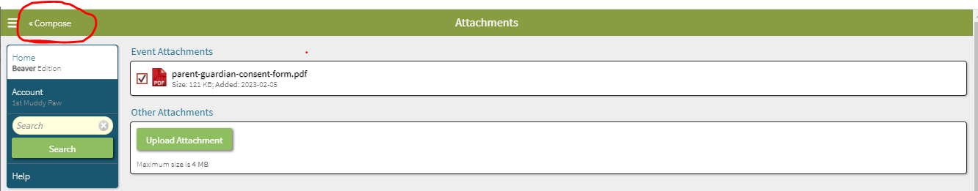
-now click on Compose; you will now see the below screen with 1 attachment
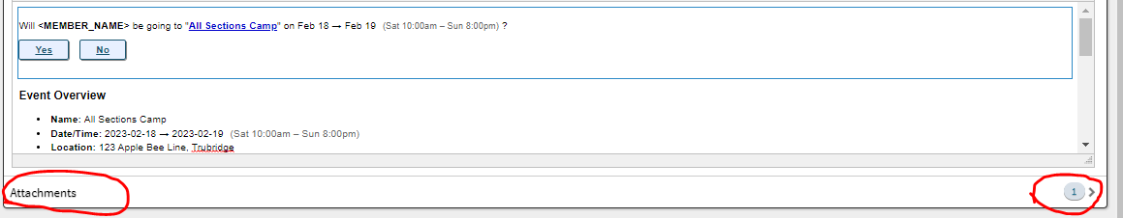
-this is the email that will be sent,
-if you want to see the full details of the email, go to the right and scroll down
-If you want to add or change any information you can do it in here before you send the email
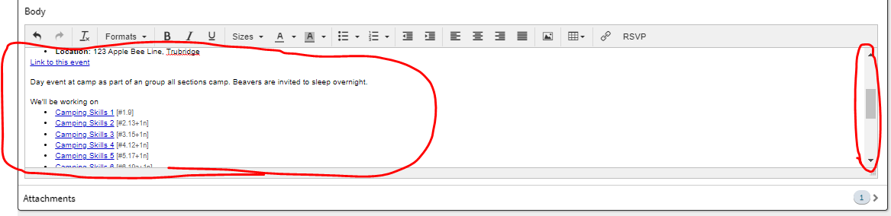
-if you decide you don’t want to send the email you can click on Discard at the bottom of the screen and the email will be gone
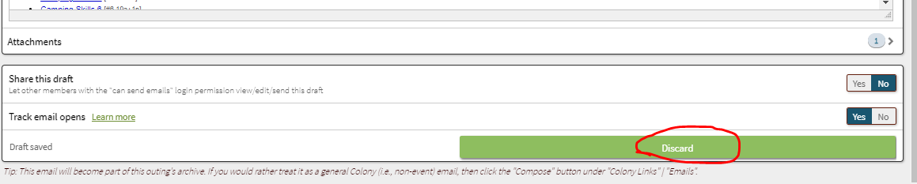
Track email options
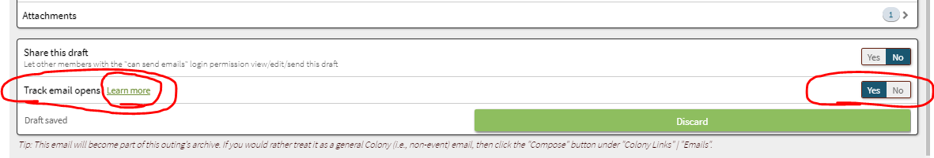
-if you click on learn more the below pop up will open and tell you your options
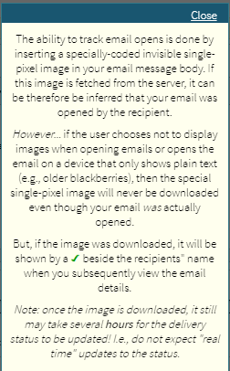
-this feature I like to leave as a yes, it is a great back up for a couple reasons
- you can see which parents open the email, so if someone isn’t responding you can check if they opened the email or not
-if a parent says they didn’t get an email you can check if it was sent to them or not
-if you have a new youth sign up and you are not sure if the email was sent to them or not you can check
If you are ready to send the email scroll to the top of page and on the right side click on Send.
You will get a pop up that says email sent and the system will take you to the event page
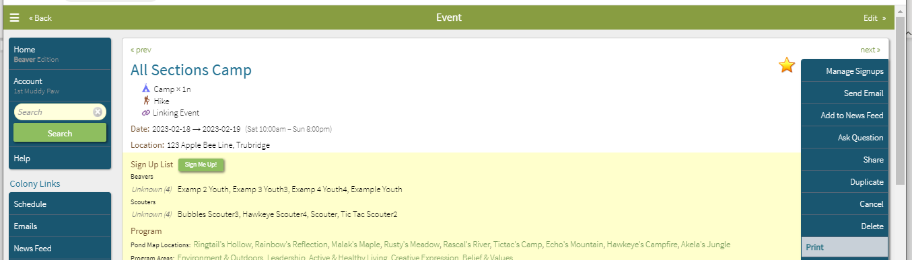

-if you want to see if an email was sent, or what the email was
-scroll to the bottom of the page

-you can see here 1 email was sent
-if you want to see the email then click on email history, you will see the screen below
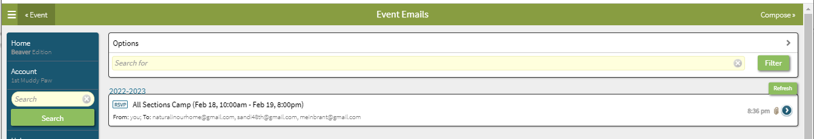
-if you click on the email, it opens so you can what was sent
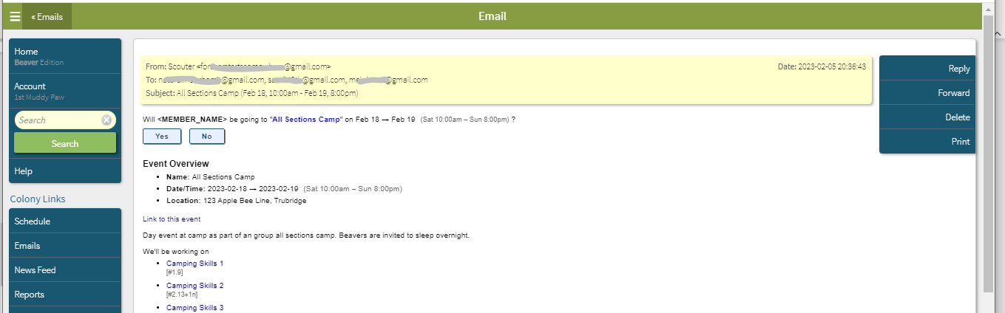
-if you scroll to the bottom, you can see the attachment here
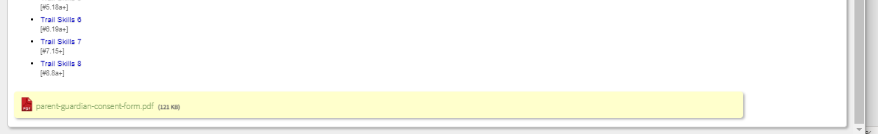
-you are now done sending the email, scroll to top, click on email on left side
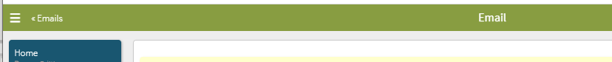
-click on Event on left side
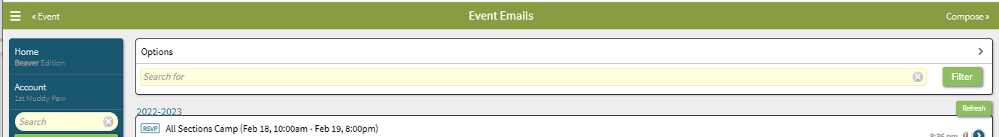
-click on Back
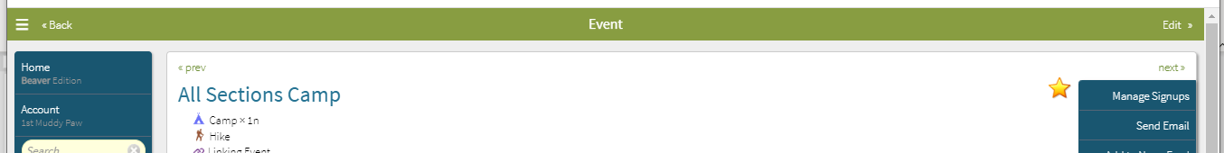
-click on Home on the top left
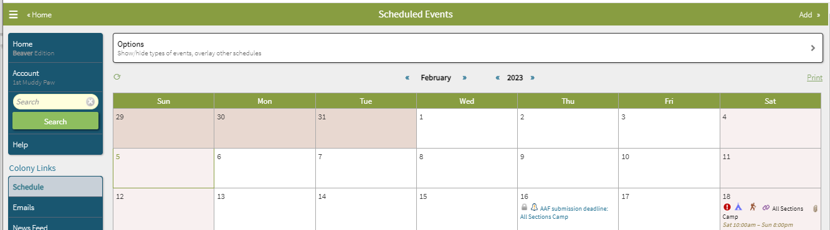
-click on Account
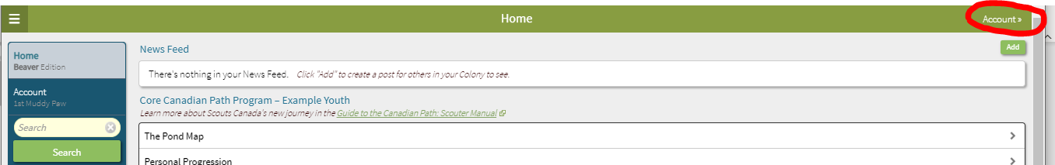
-now you can sign out
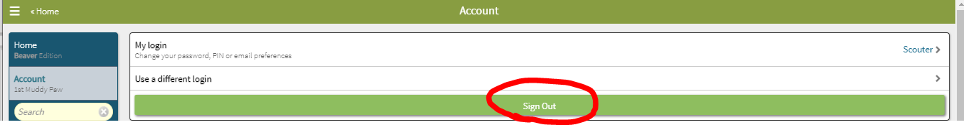
THE END

