SCOUTSTRACKER – HOW TO
CREATE AN EVENT IN YOUR SECTION SCHEDULE
Group: 1st Muddy Paw version Jan. 16, 2023
- go to the internet, go to scoutstracker.ca
- you will get the screen below
- click on the section you want to work in
- this instruction will be done in the Beaver Scouts section
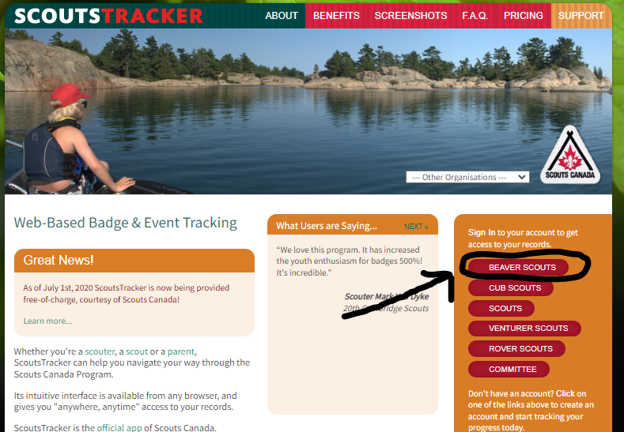
- the below screen will open, if you have an account then you can log in here
- if you click on Stay signed in for up to two weeks then you won’t have to type in email & password each time you access Scoutstracker within a 2 week timeframe, Scoutstracker will bypass this page
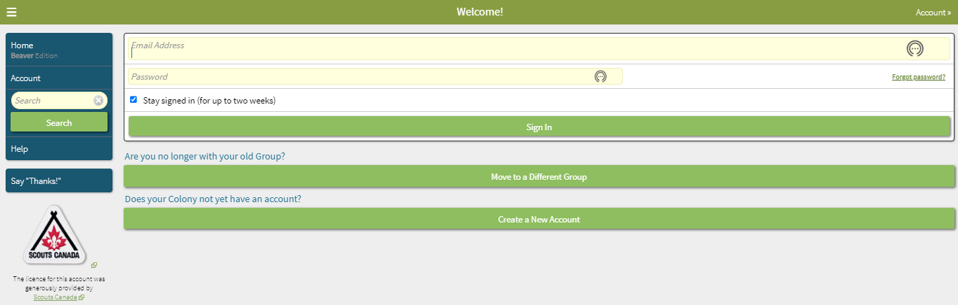
- if you are bypassing the log in screen then the below screen is what you will see next
- click on Schedule on the left side
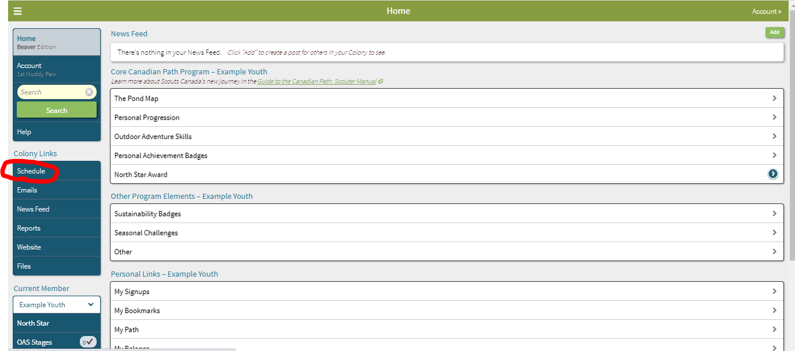
- the below screen will open
- put your curser on the day you want, you will see a + sign appear in the top right corner of
that date, click on the + sign
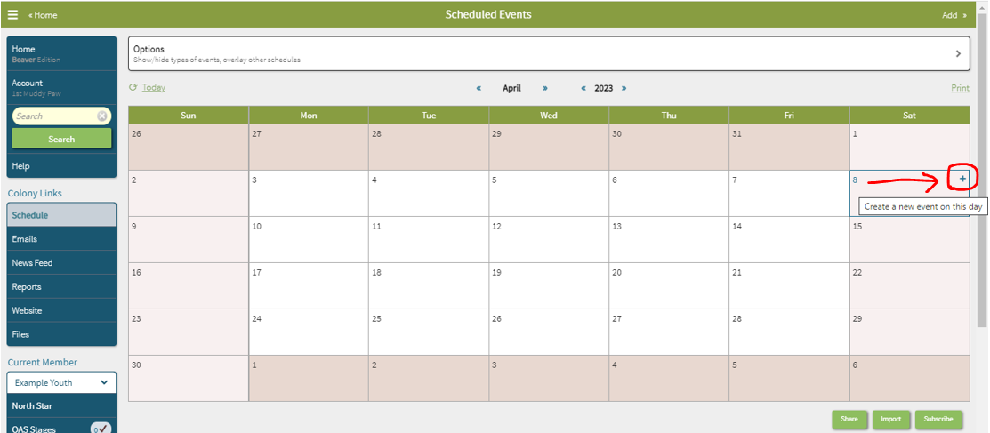

- you will now see the screen below
- click on whatever applies to the event you are creating
- this event includes a Community Service, an Environmental Project, hike, and games
- for Community Service see the right side of the line, click on it hours to choose the appropriate hours for the service,
- after choosing all that applies, click on Next at the top right side
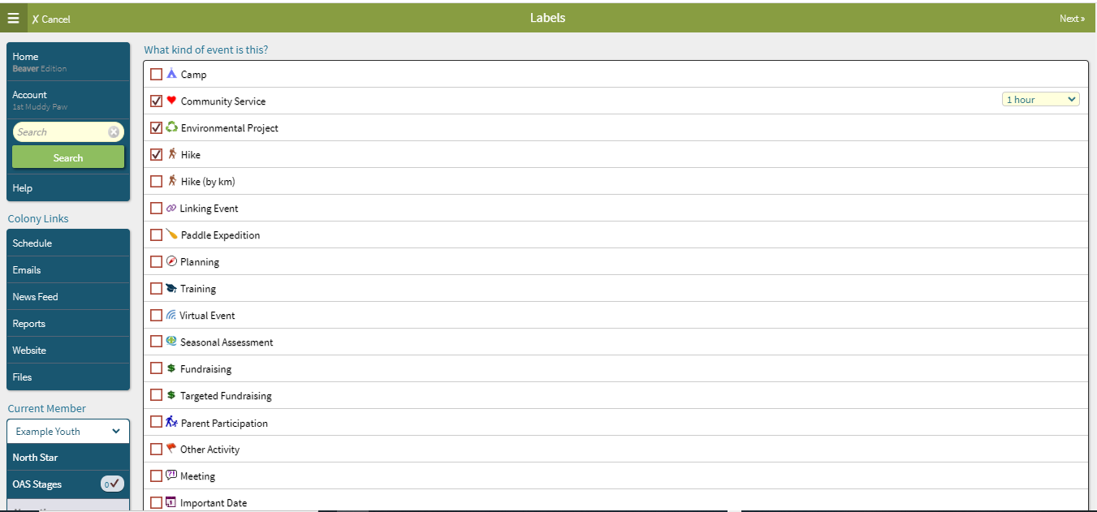

- start typing in the information for your Event/meeting
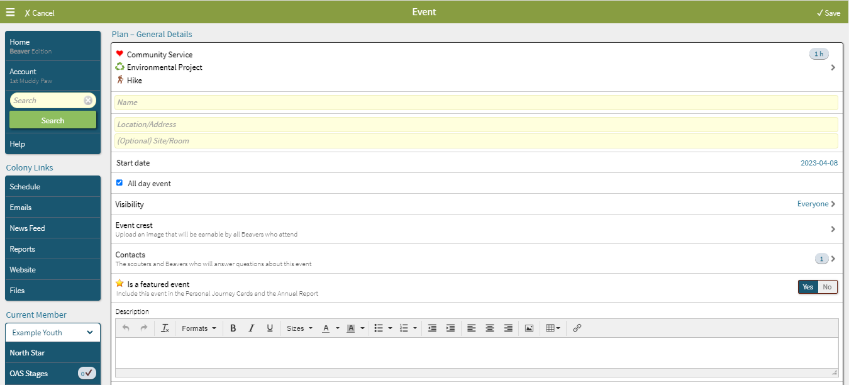
Name – give your event/meeting a name (usually reflective of what the event/meeting is about
Location/Address – of where you are meeting
(Optional) Site/Room - within the address
Start date – see it on the right, it should already be there, this self populates when you selected the date in the calendar
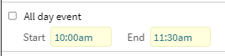
All day event – you can leave this if it is an all-day event, if you choose to unclick it then a timeframe option will appear

- your time of meeting, start and end, be sure to choose am or pm
- I like this method as it gives specific times so there is no guessing

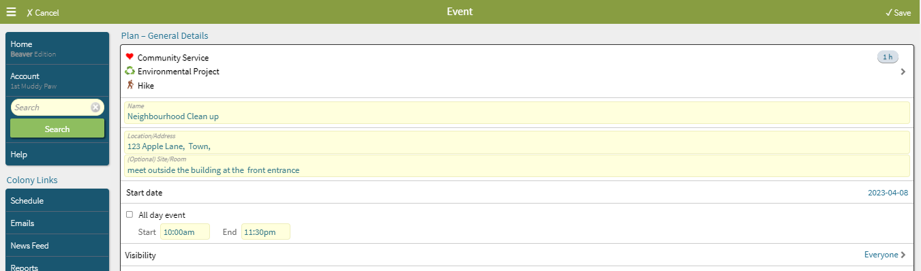
- when you click on Visibility the below options show up
- if the event was a scouter only meeting then you would click on scouters and only scouters would be able to it
- since this is a beaver event, I want everyone to see it (parents, scouters) so I choose everyone
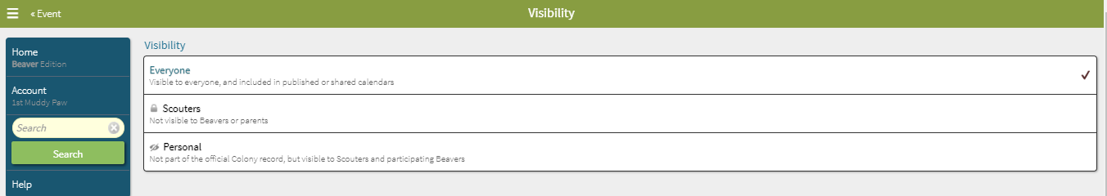
- once you click on everyone it will take you back to the previous page, if it doesn’t then click on “Event” on the green toolbar
- you can see on the Visibility line to the right, Everyone

Event Crest, this is more for an event, like a camp or beaveree, etc., if you had the crest in advance and wanted the youth to be able to see the crest, they would get by attending you could upload an image of it here
-next is contacts
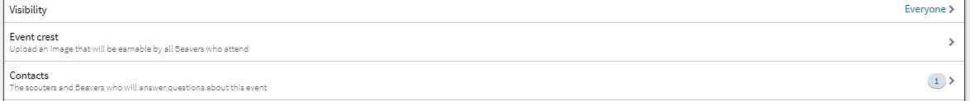
- when you click on contacts you will see a list of the beaver scouters
- click on the Scouters that will be contacts for this event, if anyone has questions, I choose all the scouters because we all planned it and can all answer questions
- next click on event at top left to go to the previous page
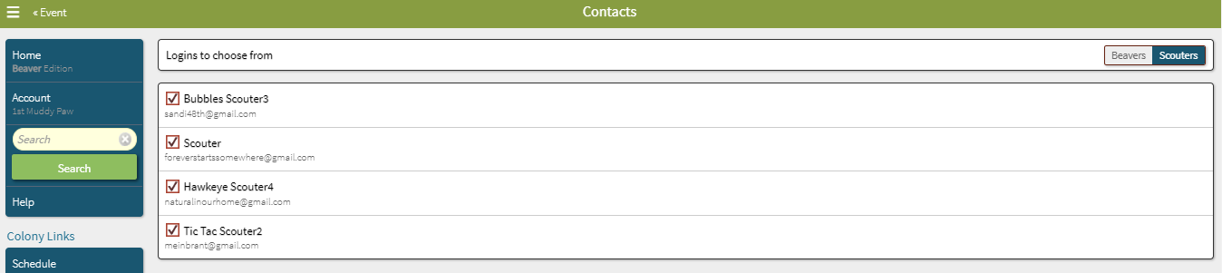
Is a featured event - this is where you decide if this event should be included in the Personal Journey Cards and the Annual Report
- if this is a special meeting like Investment, an overnight camp, etc. I would say yes by clicking on yes on the right side
- for regular meetings I personally choose no
-the event in this process involves community service so I am choosing yes

Description – this is where you type in the high-level overview of what the event is about
- everyone will be able to see these details, be sure to check spelling

Scouters notes – this area is for the scouters only and the parents cannot see these notes,
- I would still use caution as to what you put in here just in case

Transportation Plan – type in details, if an actual trip you could type in the rout to be taken, or where pit stops might happen, or any other details you want to share
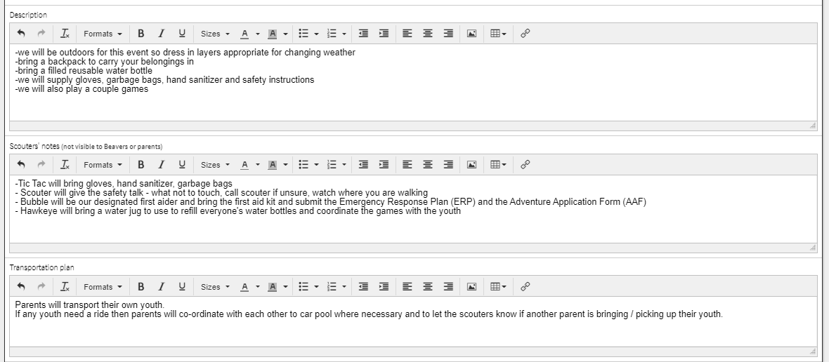
Attachments – this is where you can attach a document to this event, maybe a map of directions how to get to the event
- if a tour maybe there is a permission form that needs to be signed
- you can only add an attachment after the Event has been saved
- if you try to click on Attachments at this point, you will get a pop-up message, click close and continue down the page
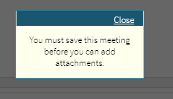
- next section is PLAN – program
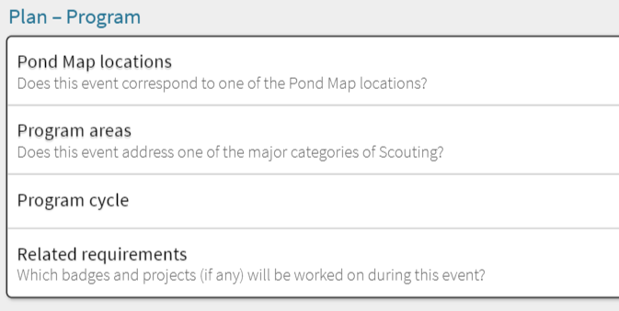
- when you click on Pond Map locations, you will see all the locations/program area and you now choose which ones that are applicable for this event
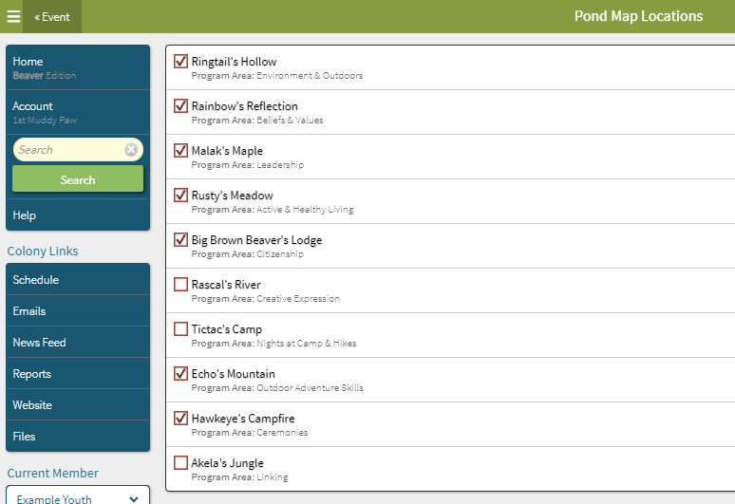
Why I choose the different Pond Map Locations:
- Ringtail’s Hollow - Environment & Outdoors – being outdoors and helping the environment by picking up garbage
- Rainbow’s Reflection - Beliefs & Values - we say the Promise and Law during opening and a prayer at closing
- Malak’s Maple - Leadership – the white tails take turns leading opening & closing ceremony; youth will also take turns leading at the games
- Rusty’s Meadow - Active & Healthy Living – we are outdoors – playing and hiking around the park
- Big Brown Beaver’s Lodge - Citizenship – helping our community by picking up garbage
- Echo’s Mountain - Outdoor Adventure Skills – we are working on some of these skills
- Hawkeye’s Campfire - Ceremonies – our opening and closing ceremony
- then click on Event at top left of page to go back to previous page

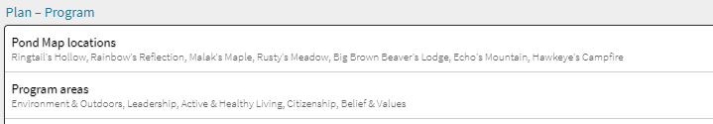
Program Areas
- you will see the choices are already filled in from the choices you made in the Pond Map Locations
- click on Event to return to previous page
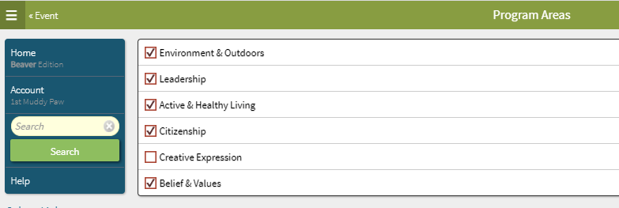
Program Cycle - this should also self populate to correspond with the season date that you are creating
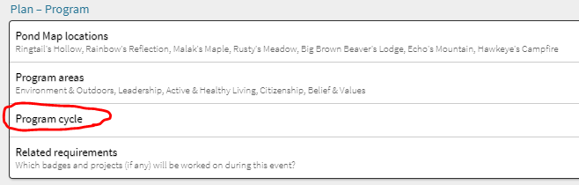
- in this case April is in Spring, see the check mark on the right beside Spring
- then click on Event to go back to previous page
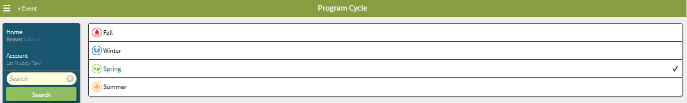
Related Requirements – you can see below, before even clicking on this line that there are already 9 requirements showing
- these have self populated from the information you have entered so far
- click on this line to check and/or add the requirements to be worked on at this event
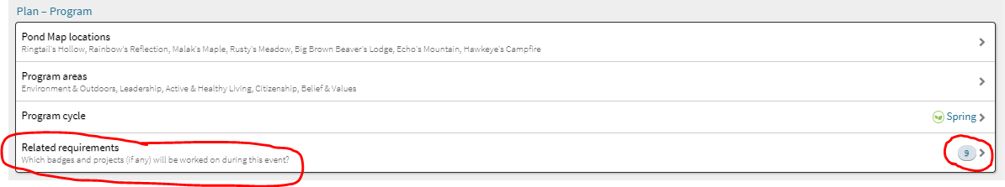
- when you click on this you will see the Badges and Projects page
- scroll down to the Outdoor Adventure Skills and / or Badges that youth will complete during this event
- if you miss any they can be added later anytime prior to finalizing this event
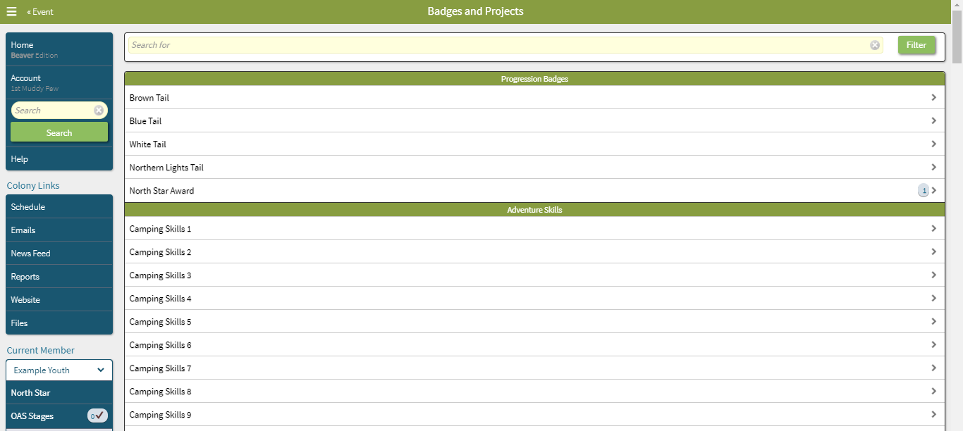
- when you click on Emergency Skills 1, you will now see the full list you click on the ones you are working on in this event, you don’t have to complete a full level in a single event
- if you are doing any of the level 2 you can just click on the right-hand side on the Next and that will take you to the level 2
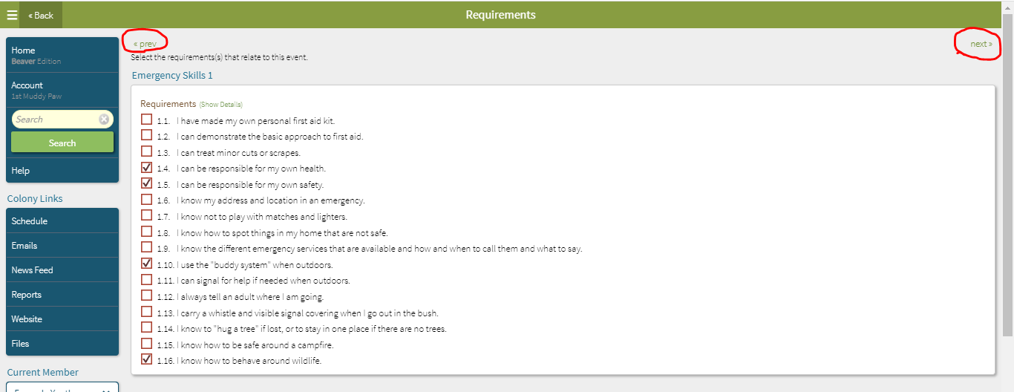
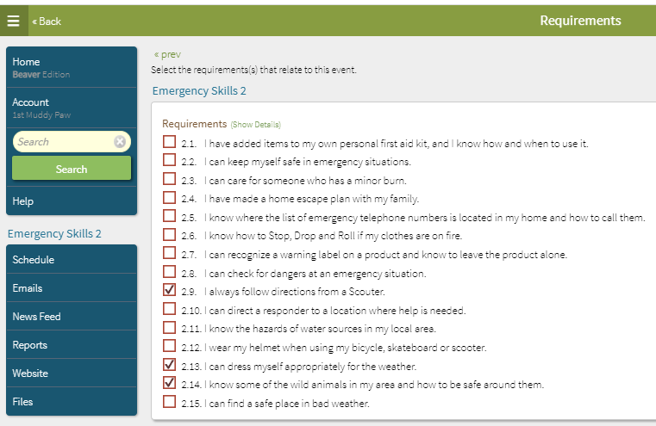
- this event also includes Emergency Skills level 2
- once you are done selecting the criteria to be worked on, click on Back on the top left on the green toolbar
- you will now see this screen, if you look at Emergency Skills 1 and 2, you will see on the right you have selected a total of 7 of the requirements
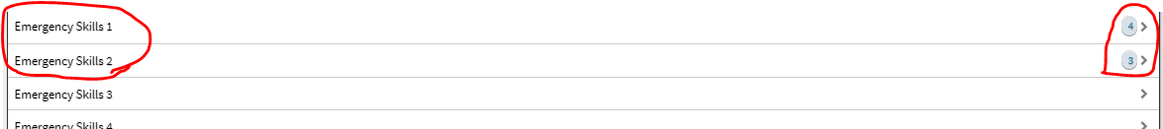
- you can scroll up and down the page to see what other requirements ScoutsTracker selected
- ScoutsTracker is smart and if you give it the full correct information it will automatically select requirements that the youth are earning, this is another reason to use ScoutsTracker vs doing this manually
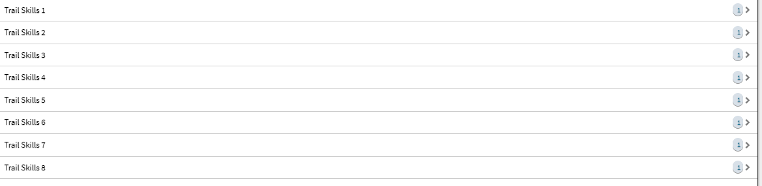
- now scroll up the page and click on Event on the green tool bar
- you can see here there are a total of 16 Related requirements the youth will do by attending this event, the Plan-Program section is now completed
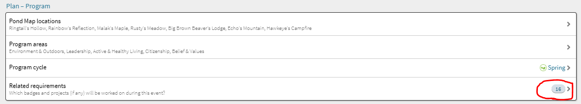

Plan – Participants section
- click on this line
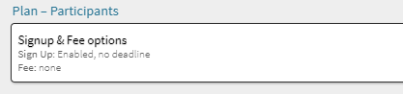
- you will then see the screen below
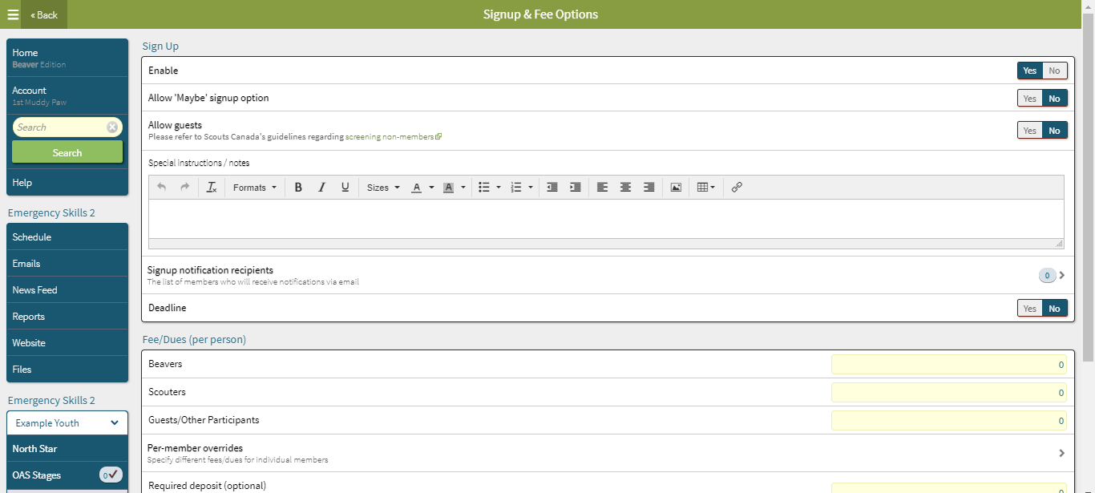
Enable – do you want to enable parents to sign their youth of for this event, this gives a nice attendance so you know how many youths to plan for
Allow “Maybe” – I personally don’t like to use this because it makes it hard for planning. Once a parent gives a “maybe” they don’t go back and give a yes or no. Of course, the decision is up to your section. If you choose NO then they only have the above Yes/No options
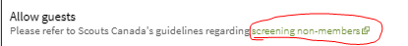
Allow guests – this is up to the section and the type of event
- be sure to check and follow Scouts Canada guidelines, if unsure of the guidelines there is a handy link “screening non-members” here for you to check, just click on the link and it will take you to the “screening non-members” process in the Scouts Canada national page, so you will always get the current version
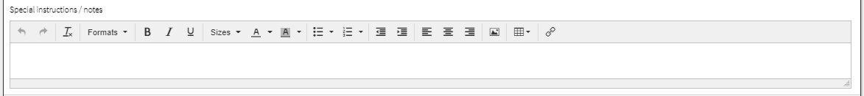
Special instructions – I personally don’t use this box because I put all my information on the front event page, but its up to you, if you want to type in here, you can
- I don’t know who can see this or where it shows up

Signup Notification – there are 2 choices here, no matter which choice you make, ScoutsTracker will still record signup in the attendance list whenever anyone does sign up
- Don’t choose a scouter and no one will receive emails. See on the right your # will be 0
- Choose a scouter to receive an email notification each time a youth signs up for this event.
- to do this click on this line
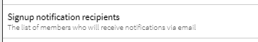
- you will now see a list of scouters to choose from
- click on whichever scouter you would like to receive an email notification each time a youth signs up for this event
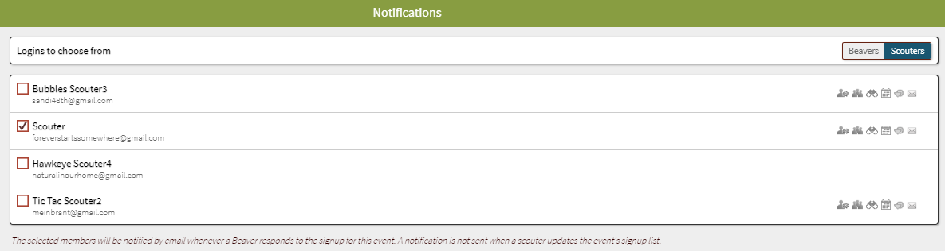
NOTE: the selected member(s) will be notified by email whenever a Beaver responds to the signup for this even. A notification is not sent when a scouter updates the event’s signup list.

- when done click back at the top left to go to previous screen
- if you choose a scouter you will see it show up here
Deadline is next, this is where you can set a deadline date to sign up for this event, or you can leave it as a NO.
If you want to set a deadline date, then click on Yes. It will open a calendar where a date can be selected. This option is useful if you need to purchase supplies ahead of time for this meeting or if it is a large event with other groups and you need to submit your registration.
- when choosing a date here be aware that the calendar opens to the present day which may be different than the event date you are working on
- in this case the calendar opened on January 12, but I am creating this event into our schedule for April 8
- for this event I am choosing not to the have a sign up deadline date
- to move the calendar, use the little arrow before and after the month and year
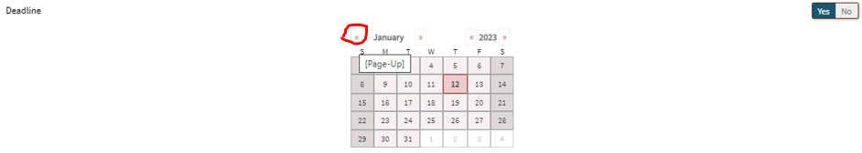
- next is Fees/Dues per person
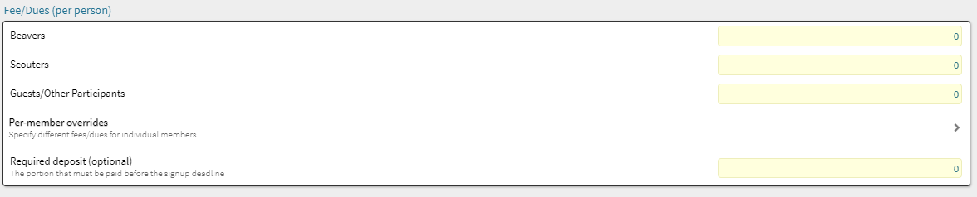
- if you are not charging anything then don’t do anything here and it will remain as 0
- if you are charging a fee for the event or dues at your meetings then you will add it in here and let ScoutsTracker do the tracking for you
- if this event was a tour, council event, etc. and there is a fee to pay this is where you can enter it - if the fee was $5.00 each then you would click on Beavers line, type 5, click on scouters type 5, click on Guests type in 5
Per member overrides- use this to override the data for a particular person
- this could be used if a parent paid dues for the whole month, then you enter the dues on the date paid and the next 3 weeks you would enter 0
- once you click on the per member override line a list of your section will show up
- this is where you would choose the participant and type in the override amount
- once you are done click on Back to go to previous screen
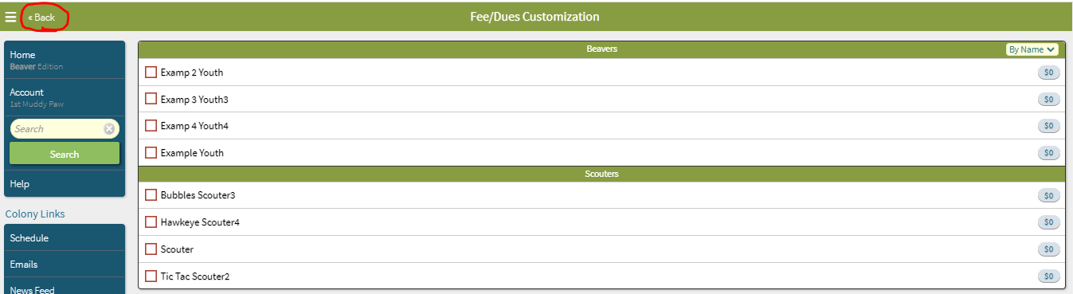
- you will see the below screen
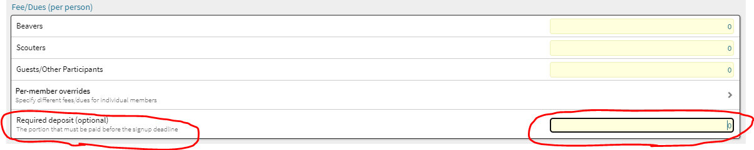
Required Deposit (optional) – if you require an upfront deposit for an event, tour, camp, etc. this is where you could enter it
- you would just click on the line and type in the amount of the deposit required, this amount is the same for everyone, you cannot do a separate amount for scouters and youth

- you are now done this section, scroll to the top of the page and click on Back
- you will now see the below screen with a list of youth and scouters who are eligible to sign up for this event
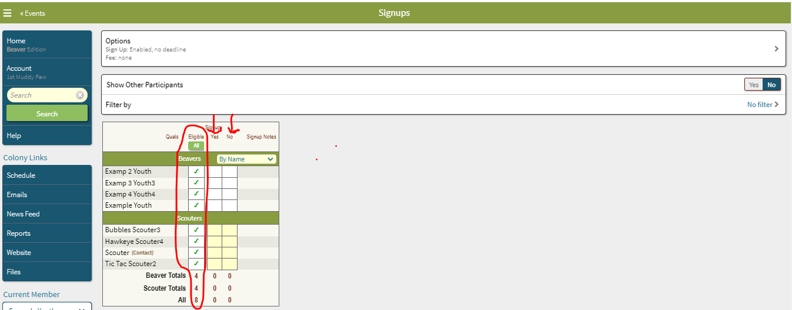
- as the youth sign up you will see check marks show up in the Yes & No columns
- for this event I didn’t allow any Maybe signups, if I had then you would also see a Maybe column
- when parents sign up, they can also put in a comment which will show up here as well
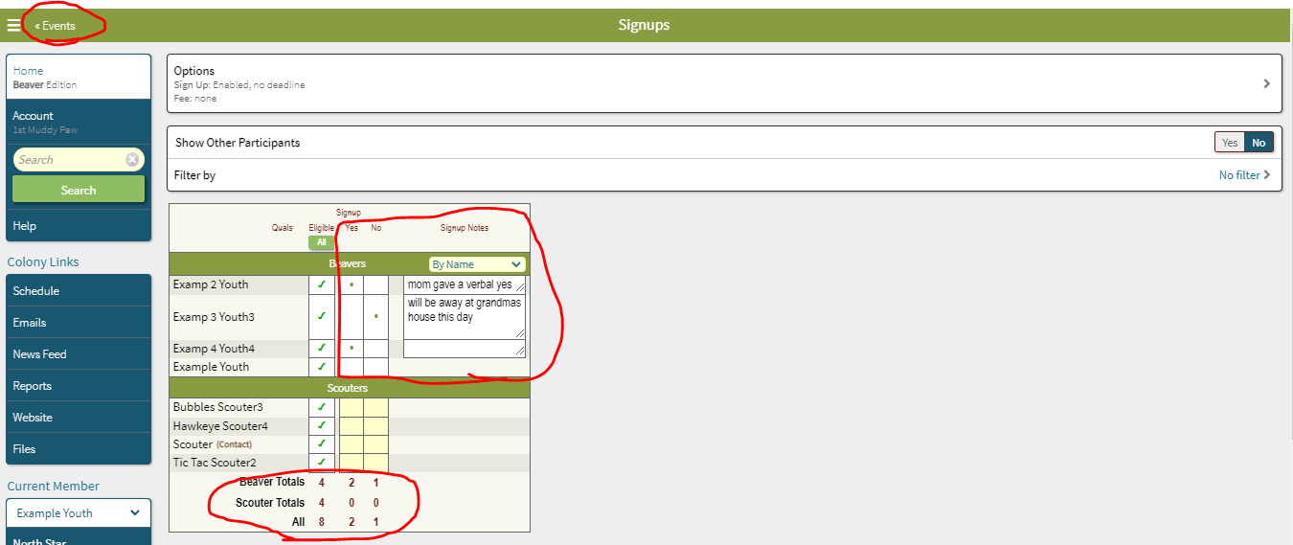
- scouters can also put in responses just by clicking on the space
- scouters can also put in comments by clicking on the notes box and type
- you will also see the totals at the bottom of each column
- when done on this page go to top left and click on Event to go to previous page

-next is Plan – Risk Management
Risk category – ScoutsTracker will tell you which category this event is, if you put in all the correct information, if you want to check to make sure you are in the right category then click on this line
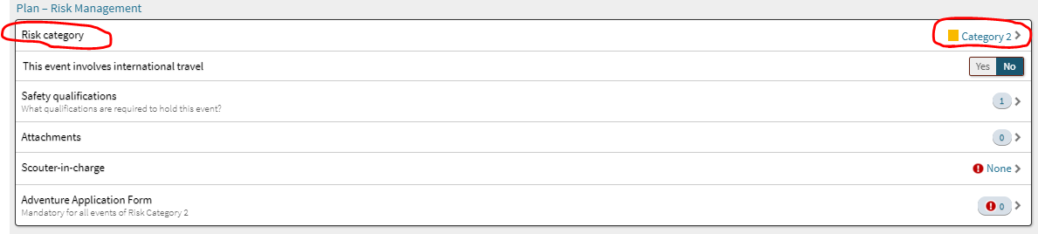
- once you click on Risk Category, you will see the message below,
- if you want more details click on “Learn more” 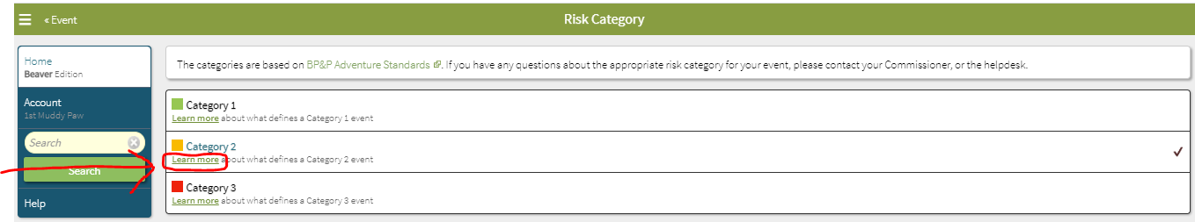
- the below screen will open with the definitions of each category
- when done click on back 2 times to go back to the event page
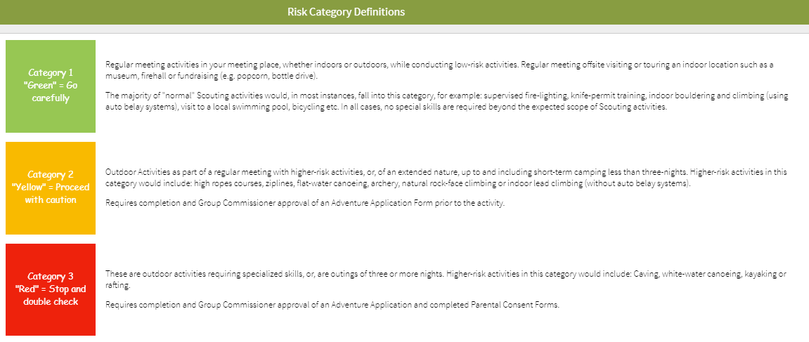
International travel - yes or no
Safety qualifications – on the right it states 1, this means there is 1 qualification needed
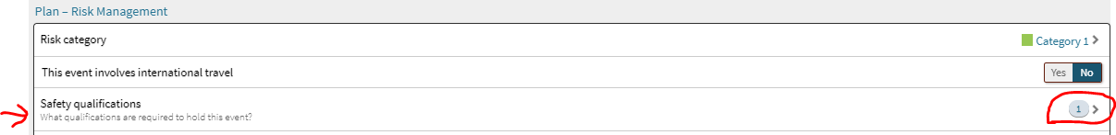
- to find out what is needed, click on the line and the below screen will open

- you can see for this event you need Standard First Aid to be held by 2 participants
- click on the Event at top left of page to go back to previous page
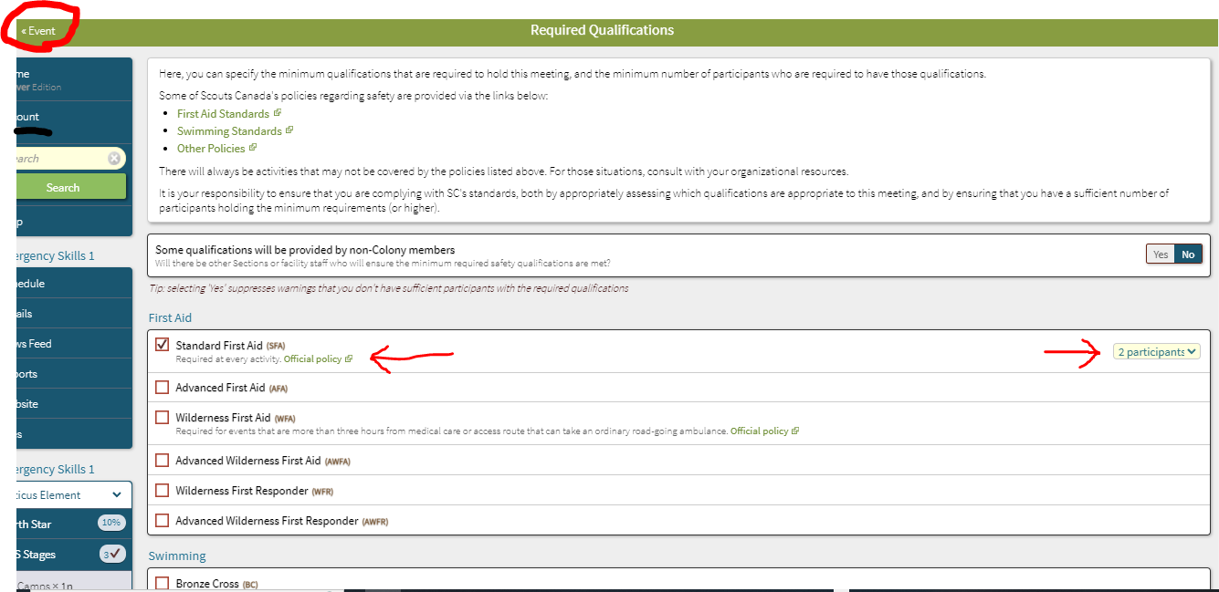
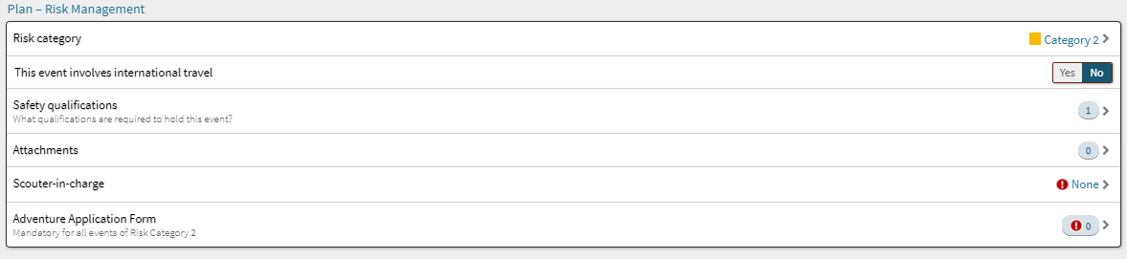
Attachments – this event needs to be saved before you can add any attachments, this is where you would add your Emergency Response Plan (ERP) when an Adventure Application Form (AAF) is required
Scouter in charge – it may self populate, in the above screen it shows non
- the Scouter-in-charge is the one for this particular event, the one who will hold the section paperwork, register for event, etc.
- to populate or change the Scouter-in-charge, click on this line and a list of scouters will show up as seen below,
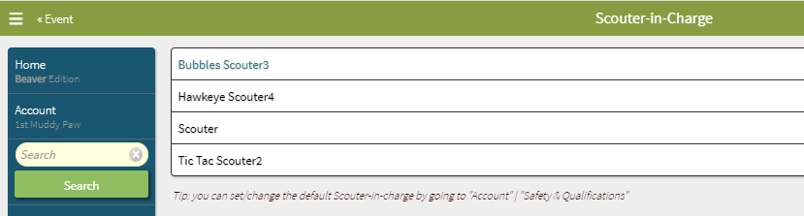
- click on the line of which scouter you would like for this event, as soon as you click on the scouter you will be taken back to this screen
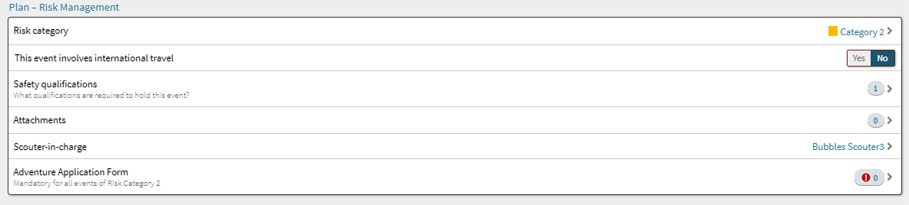
Adventure Application Form (AAF) – if the event is a category 1 you don’t need this step
- if the event is a category 2 or 3 then an AAF is required
- submitting the form through ScoutsTracker is so easy, quick and simple
- the meeting needs to be saved prior to doing the form, if you try to do it now you will get a pop telling stating the meeting needs to be saved

Review is done after the event,
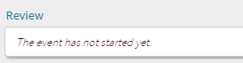
- if you try to do it now you will get this pop up
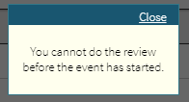

SAVE
- we are at the end of creating this event,
- scroll to the top of the page, on the right side click on Save
- if you don’t save you will loose everything you just input
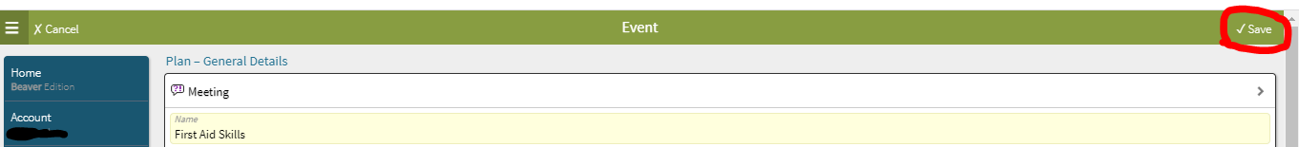
- once you click save the screen below will appear
- you can see where it is telling you that you still have things to do
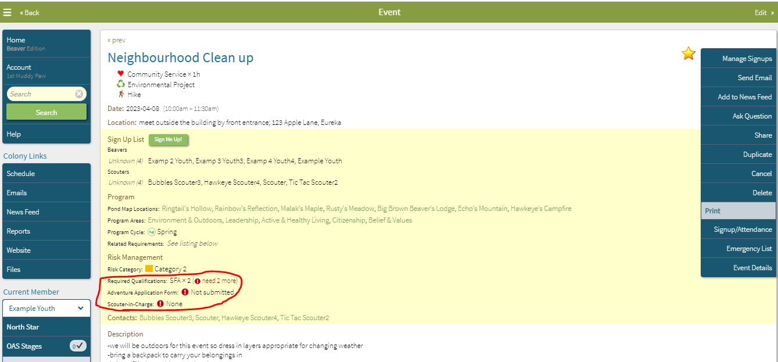
After saving this event you will need to finish these items.
At this point you can go to “Schedule” on the left and enter another event on another date or you can log out and be finished.
THE END

